1. Flashback:
2. Sometimes, we make decisions without thinking too much about them, such as deciding how to drive to work.
3. Other times, we sit and imagine many possible scenarios based on our understanding of the world. We can use these imagined outcomes to decide what to do or what not to do. For example, if we carry a fragile object with one hand, we can imagine scenarios where it falls and breaks and we can make choices accordingly.
4. .
5. We've seen sample-based methods like TD which learn only from sampled experience.
6. .
7. We've also seen methods like dynamic programming or DP which plan by using complete information about how things work, without having to make decisions.
8. .
9. .
10. It would be even better if we could obtain an intermediate method that can leverage the best of both extremes.
11. .
12. This week, we will do just that and unify these strategies with the Dyner architecture. In this video, we will talk about models.
13. .
14. .
15. 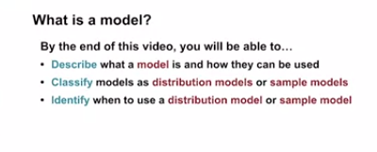
16. .
17. .
18. .
19. . Models are used to store knowledge about the dynamics. When imagining different scenarios to a decision-making, this is rooted in our knowledge about how the world works.
20. .
21. . 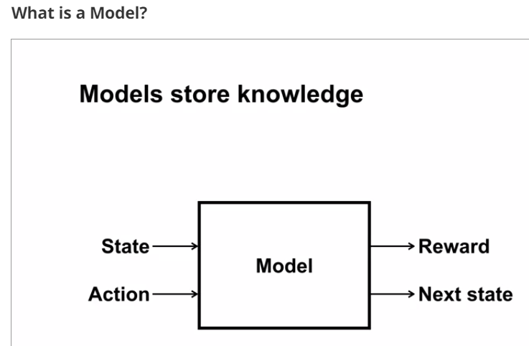
22. .
23. From a particular state in action, the model should produce a possible next state and reward. This allows us to see an outcome of an action without having to actually take it.
24. .
25. .
26. A model allows for planning. Planning refers to the process of using a model to improve a policy.
27. .
28. .
29. . 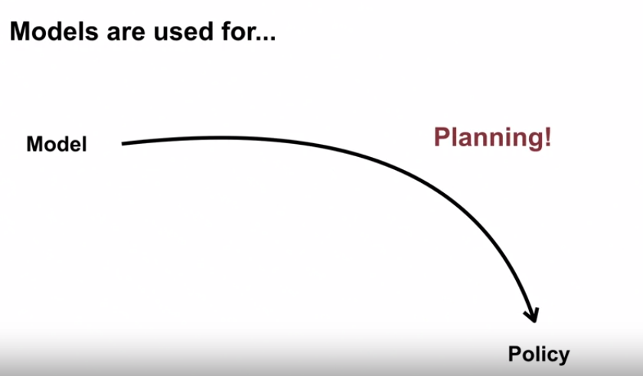
30. .
31. One way to plan with a model is to use simulated experience and perform value function updates as if those experiences happened. By improving the value estimates, we can make more informed decisions.
32. .
33. Simulating experience improves the sample efficiency. The addition of simulated experience means the agent needs fewer interactions with the world to come up with the same policy.
34. .
35. .
36. . 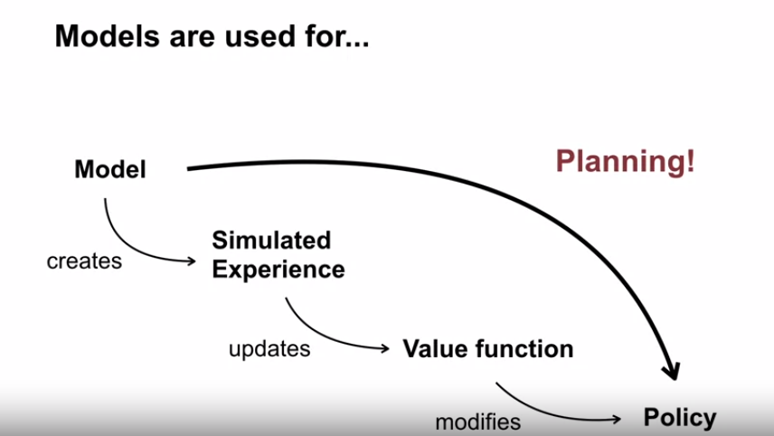
37. .
38. Now, let's talk about the different types of models that may be useful to us.
39. .
40. One is a sample model, which produces an actual outcome drawn from some underlying probabilities.
41. For example, a sample model for flipping a coin can generate a random sequence of heads and tails.
42. .
43. . 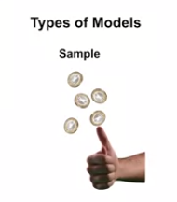
44. .
45. Another type of model is a distribution model which completely specifies the likelihood or probability of every outcome.
46. In the coin flipping example, it would say that heads could occur 50 percent of the time and that tails could occur 50 percent of the time. It could also produce the odds of any sequence of heads and tails using this information.
47. .
48. . 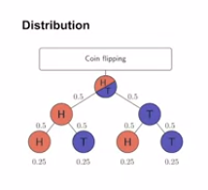
49. .
50. Sample models can be computationally inexpensive because random outcomes can be produced according to a set of rules.
51. For example, to flip five coins, a sample model can randomly pick zero or one independently five times. It only needs to produce a single outcome for each flip.
52. . 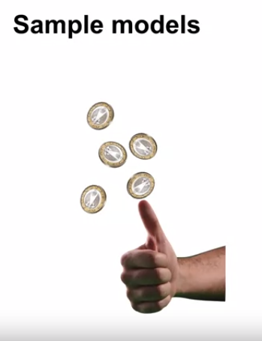
53. .
54. As an example of a sample model in practice, in 2017, the company CloudFlare use random patterns sampled from a wall of lava lamps to encrypt 10 percent of global Internet traffic. The samples are random configurations of the lava lamp wall at a given point in time with the procedure of rules to generate those samples defined by the dynamics of the lava lamps.
55. .
56. . 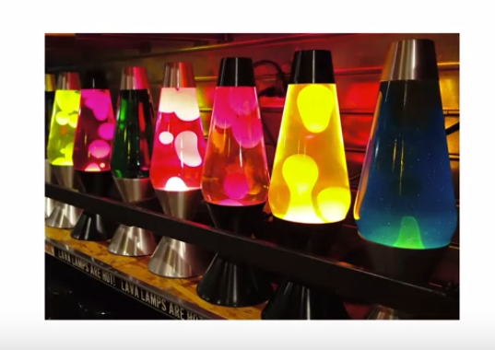
57. .
58. .
59. Distribution models contain more information, but can be difficult to specify and can become very large.
60. .
61. Let's go back to the example for flipping five coins. A distribution model would enumerate every possible sequence of heads and tails you could get across the five coins and assign a probability to each sequence. For this simple problem, that would consist of fully describing 32 possible outcomes.
62. .
63. Distribution models can be used as sample models by drawing outcomes according to explicit probabilities of each outcome. But they contain more information that might be strictly needed just to obtain samples.
64. .
65. In this video, we talked about how models can be used to improve a policy through a process called planning.
66. We discussed two different types of models, sample models and distribution models. Next time, we'll go into more depth on the differences between these models.
67. .
68. .
69. 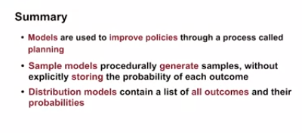
70. .
71. .
72. Models represent knowledge of how the world works.
73. We've talked about two types of models; sample models and distribution models.
74. .
75. .
76. . 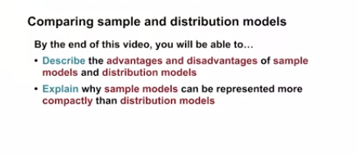
77. . 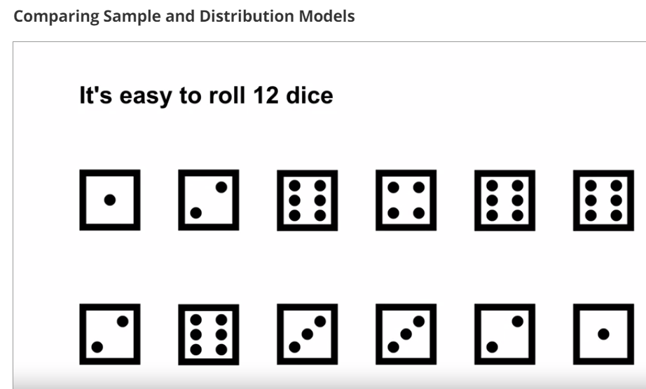
78. Let's consider the problem of rolling 12 dice. This can be done easily with a single die and enough patience.
79. Rolling a single die 12 times is an example of a sample model.
80. . 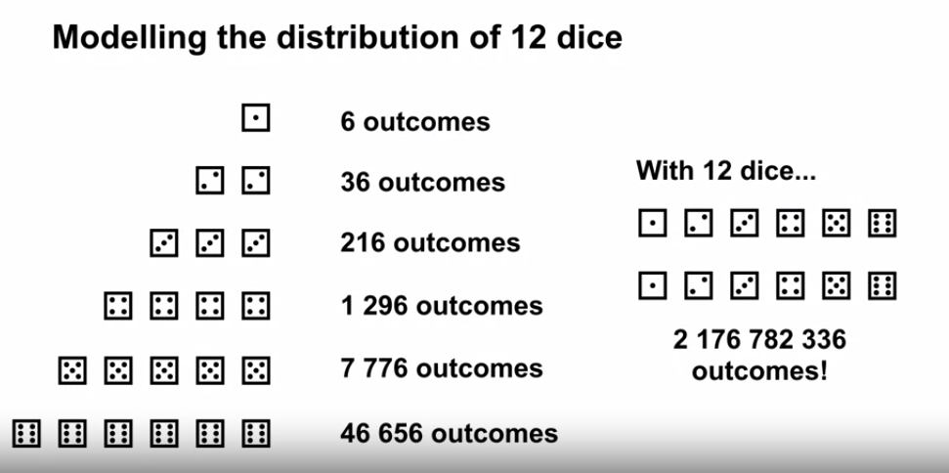
81. .
82. Programmatically, one would generate a random number from 1-6, 12 times.
83. This is very compact and does not consider joint probabilities.
84. Modelling the complete joint distribution of rolling 12 dice is much more work. We must consider every possible outcome of 12 dice and assign a probability to each outcome. With one die, we have six outcomes with two dice, we have 36 outcomes, three has 216, four has 1,296, and by the time we get to 12 dice, we have over 2 billion possible outcomes to consider.
85. But it can be useful that a distribution model produces the exact probability of an outcome.
86. .
87. For example, we can compute the expected outcome directly or quantify the variability in outcomes.
88. .
89. .
90. Let's summarize the benefits of each type of model.
91. .
92. Sample models require less memory.
93. Distribution models on the other hand can be used to compute the exact expected outcome by summing over all outcomes weighted by their probabilities.
94. .
95. . 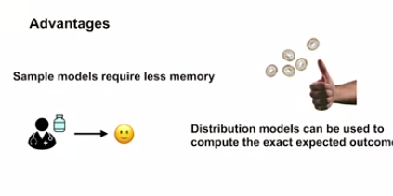
96. .
97. Note that sample models can only approximate this expected outcome by averaging many samples together, knowing the exact probabilities also has the flexibility of assessing risk.
98. . 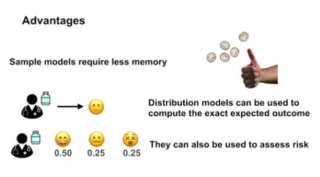
99. .
100. For example, when a doctor is prescribing medicine, they would consider many possible side effects and how likely they are to occur.
101. .
102. In this video, we described how sample models can be more compact than distribution models, and how the explicit probabilities and distribution models can be useful in some situations, such as for computing expectations.
103. .
104. 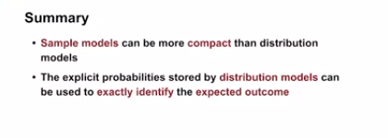
105. .
106. .
107. .
108. Now that we know what models are, we can discuss how we might use them in reinforcement learning.
109. That is, how one can leverage a model to better inform decision-making without having to interact with the world, we call this process planning with model experience.
110. .
111. In this video, we will talk about one particular view of planning. By the end of this video, you'll be able to explain how planning is used to improve policies and describe one step tabular queue Planning.
112. .
113. . 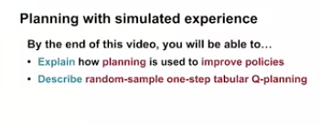
114. Planning is a process which takes a model as input and produces an improved policy.
115. .
116. . 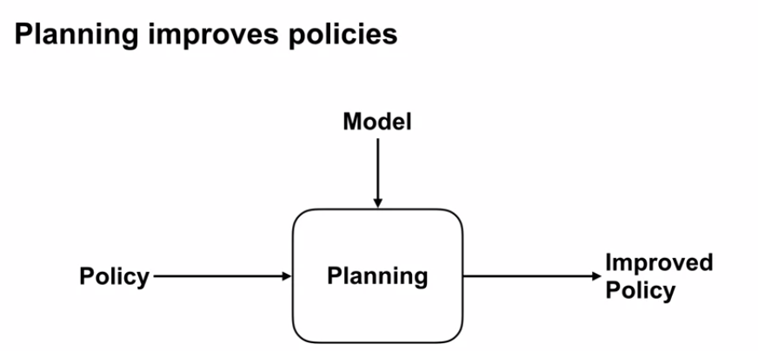
117. .
118. One possible approach to planning is to first sample experience from the model. This is like imagining possible scenarios in the world based on your understanding of how the world works.
119. This generated experience can then be use to perform updates to the value function as if these interactions actually occurred in the world. See below.
120. .
121. . 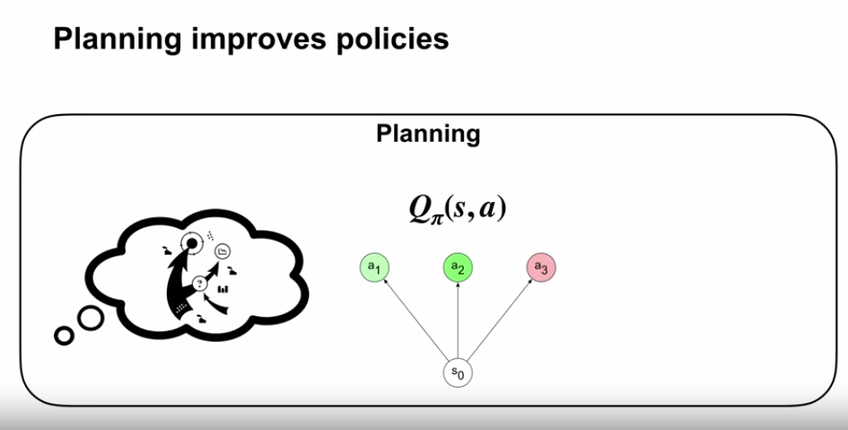
122. .
123. .
124. Behaving greedily with respect to these improved values results in improved policy. See below
125. .
126. . 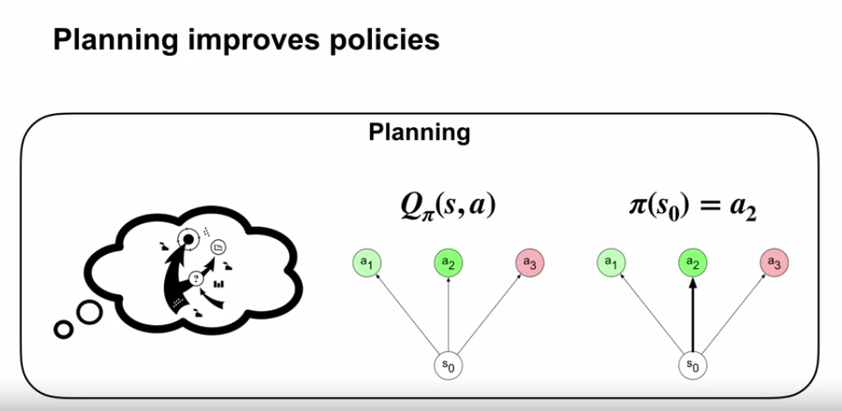
127. .
128. Recall that Q-learning uses experience from the environment, they performs an update to improve a policy.
129. .
130. . 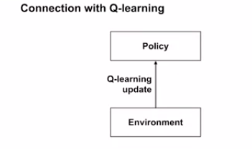
131. .
132. In Q-planning, we use experience from the model and perform a similar update to improve a policy.
133. .
134. . 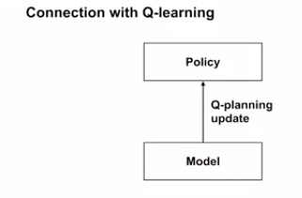
135. .
136. Random-sample one-step tabular Q-planning illustrates this idea.
137. This approach assumes we have a sample model of the transition dynamics.
138. It also assumes that we have a strategy for sampling relevant state action pairs.
139. One possible option is to sample states and actions uniformly.
140. .
141. .
142. .
143. 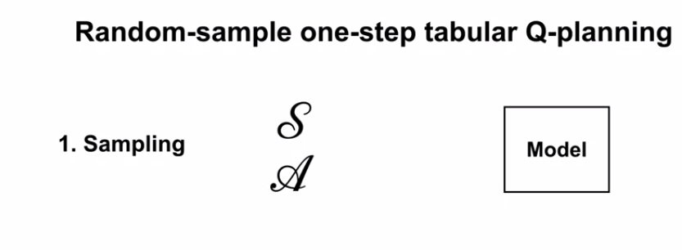
144. .
145. .
146. .
147. This algorithm first chooses a state action pair at random from the set of all states and actions. It then queries the sample model with this state action pair to produce a sample of the next state and reward.
148. .
149. . 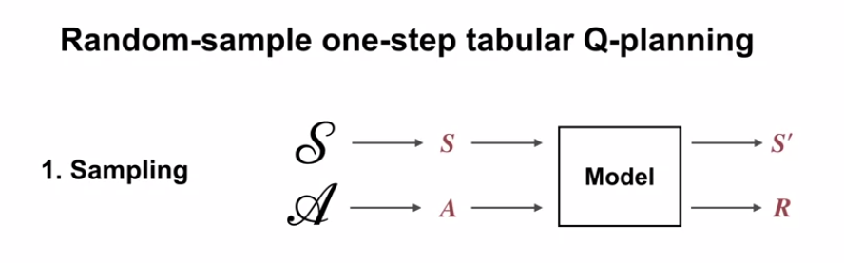
150. .
151. It then performs a Q-Learning Update on this model transition. Finally, it improves the policy by beautifying with respect to the updated action values.
152. .
153. .
154. . 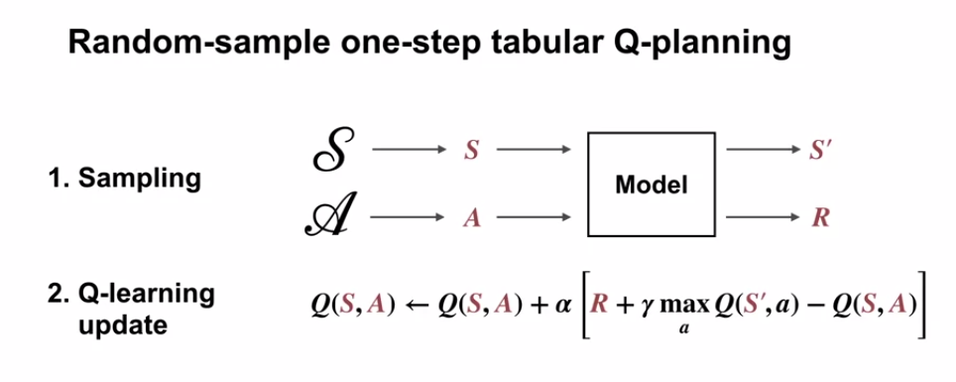
155. .
156. .
157. .
158. 
159. A key point is that this planning method only uses imagined or simulated experience. All of these updates can be done without behaving in the world or in parallel with the interaction loop.
160. .
161. . 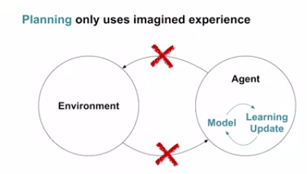
162. .
163. .
164. .
165. Imagine that actions can only be taken as specific time points, but Learning updates can be executed relatively fast.
166. This results in some waiting time from after the Learning Update and when the next action is taken. We can fill in this waiting time with Planning Updates.
167. .
168. . 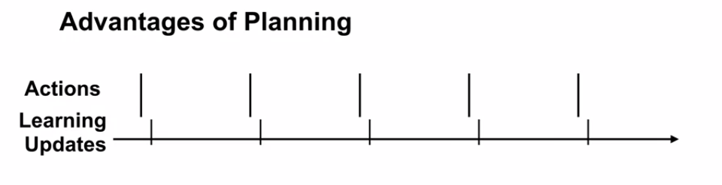
169. .
170. .
171. We can fill in this waiting time with Planning Updates.
172. .
173. 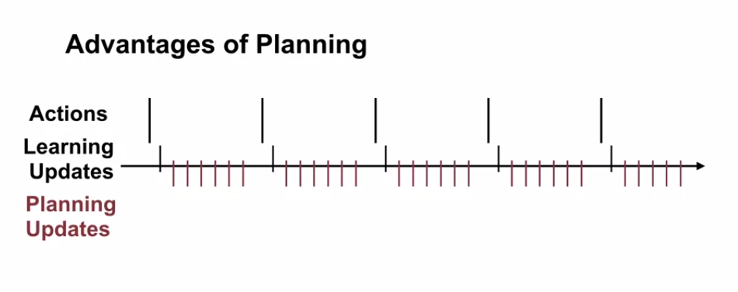
174. .
175. .
176. .
177. Imagine we have a robot that is standing near a cliff. Let's say it's model knows about the outcome of stepping off of the cliff, but it is not accurately represented in its value function or policy. It can generate simulated experience of stepping off of the cliff and perform many planning steps on these transitions.
178. .
179. .
180. . 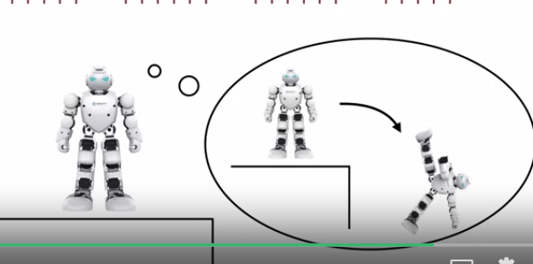
181. It's value functional now better reflect that stepping off of the cliff is bad, and it's policy will have its step away from the cliff.
182. .
183. . 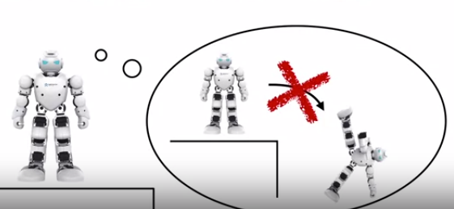
184. .
185. To summarize, we discussed how planning methods use simulated experience to improve policies, how random sample once I've tabular Q-planning uses a sample model to randomly generate experience, and how the value function is then improved using a Q-Learning update.
186. 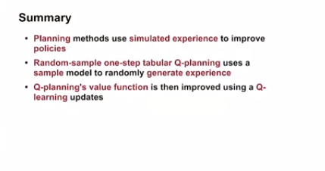
187. .
188. .

#### .. The Dyna Architecture

1. 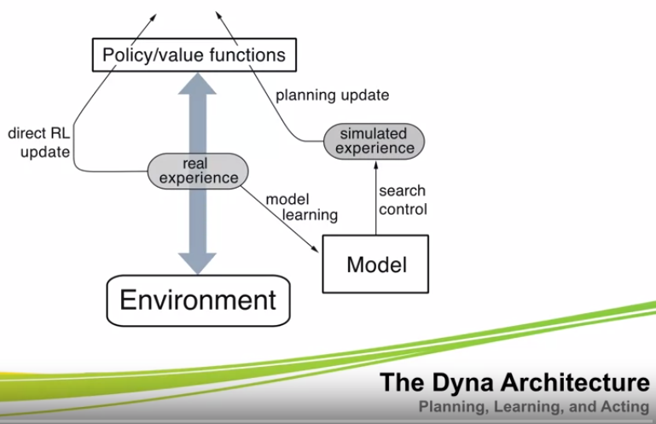
2. .
3. .
4. .
5. . So far, we've talked about two sources of experience. The environment and the model.
6. In direct RL, the agent learns from experience generated by interacting with the world like in Q-learning, but the agent can also generate simulate experience from the model and use it for planning.
7. .
8. .
9. .
10. we will talk about one way to combine direct RL and planning called Dyna.
11. .
12. .
13. . 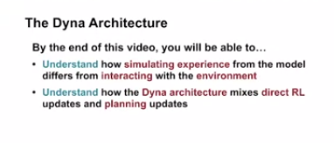
14. .
15. .
16. . We've seen Q-learning which performs updates using environment experience.
17. . Q-planning on the other hand performs updates using simulated experience from the model
18. .
19. .
20. .
21. .
22. . We can combine these two ideas through the Dyna architecture. First, we will describe the main components of Dyna. We have the usual environment and policy.
23. .
24. 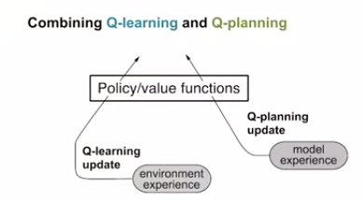
25. .
26. They generate a stream of experience. We use this experience to perform direct RL updates.
27. .
28. 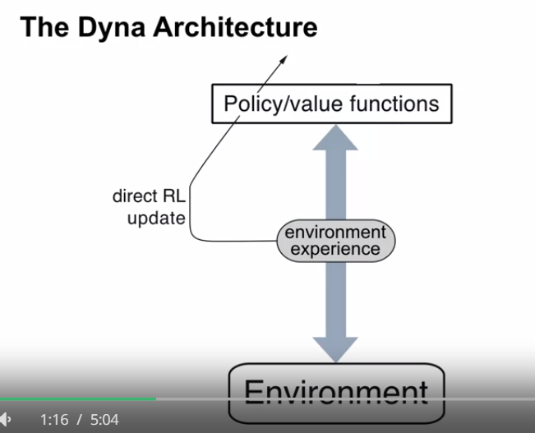
29. .
30. To do planning, we need a model. The model has to come from somewhere.
31. .
32. .
33. .
34. . The environment experience can be used to learn the model.
35. .
36. .
37. . 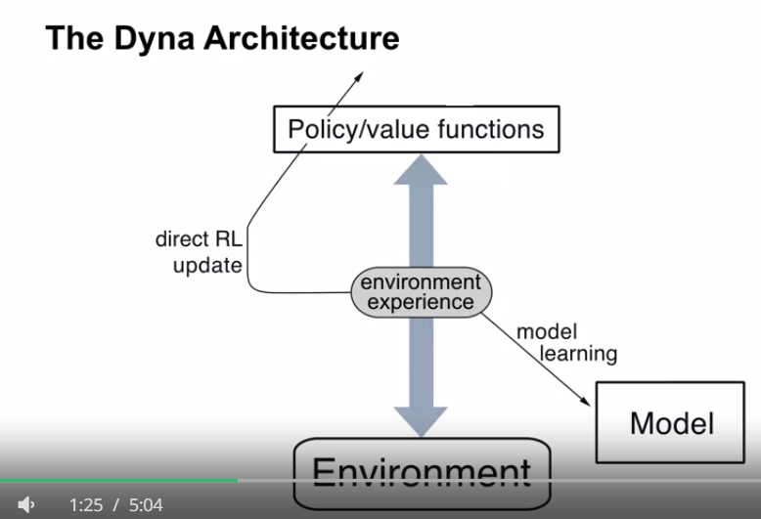
38. .
39. .
40. .
41. .
42. This model will be used to generate model experience.
43. .
44. 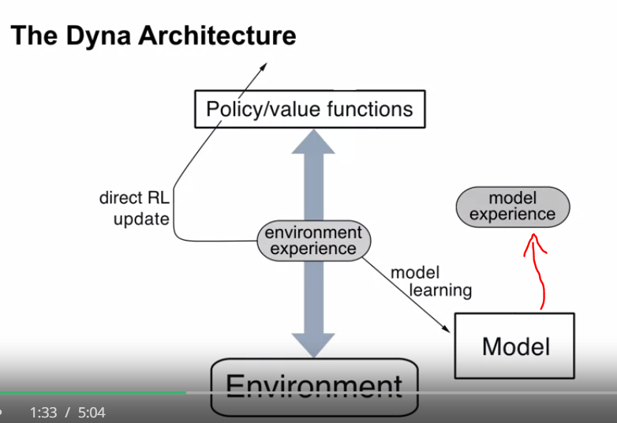
45. .
46. .
47. .
48. In addition, we want to control how the model generates this simulated experience, what states the agent will plan from. We call this **process search control**.
49. .
50. . 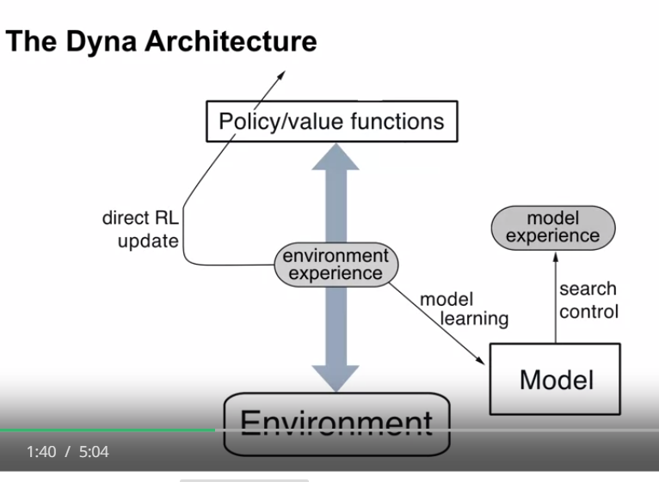
51. .
52. .
53. . Planning updates are performed using the experience generated by the model.
54. .
55. . 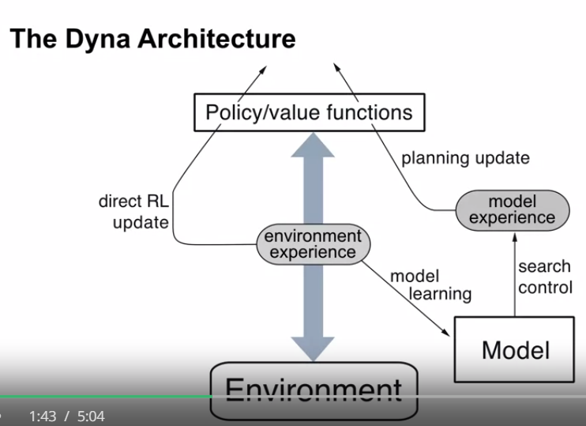
56. .
57. .
58. 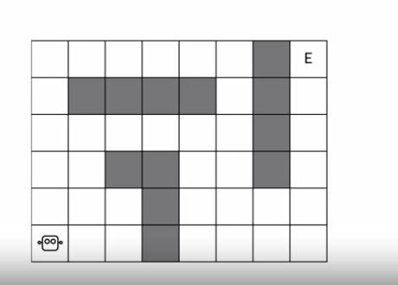
59. .
60. . Let's look at a cartoon of how Dyna works. Here we have a simple maze and a robot trying to find its way out. It's a discounted problem. The robot receives a reward of plus 1 at the goal and 0, otherwise
61. .
62. .
63. . 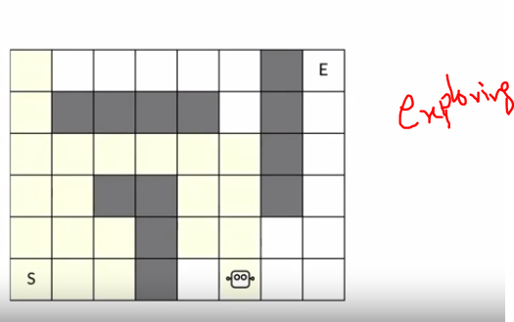 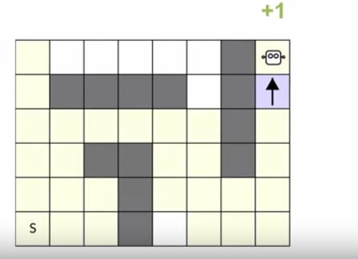
64. .
65. . It randomly traverses the maze until it stumbles on the goal for the first time.
66. .
67. .
68. .
69. .
70. .
71. . A robot only updates one action value depicted in blue. This was the only transition that generated nonzero reward.
72. .
73. .
74. . 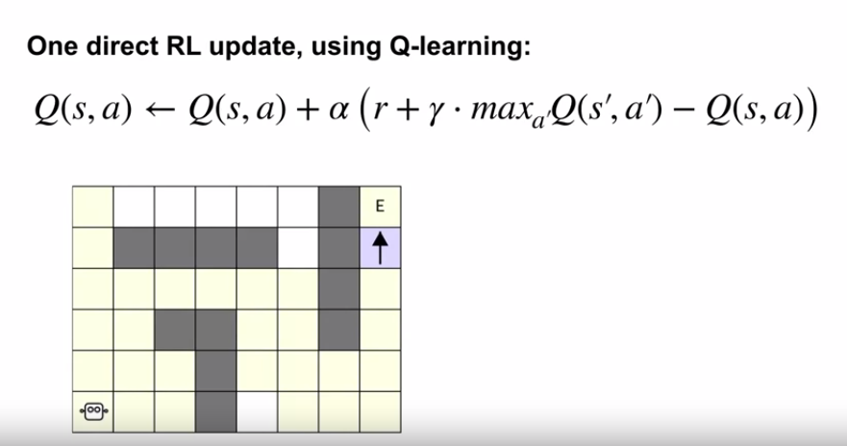
75. .
76. .
77. This update is done by direct RL.
78. .
79. Dyna makes use of all the experience generated during the first episode to learn a model the environment.
80. The yellow states correspond to states visited during the first episode. The robot didn't visit all of them, but it visited most of them.
81. .
82. Dyna performs planning on every time step. However, planning has no impact on the policy during the first episode even though the model became more accurate on each time step.
83. After the first episode completes, planning can really shine. In our cartoon, the thought bubble represents planning happening in the robot's mind. The grid world in the bubble represents the robots model of the world.
84. .
85. .
86. 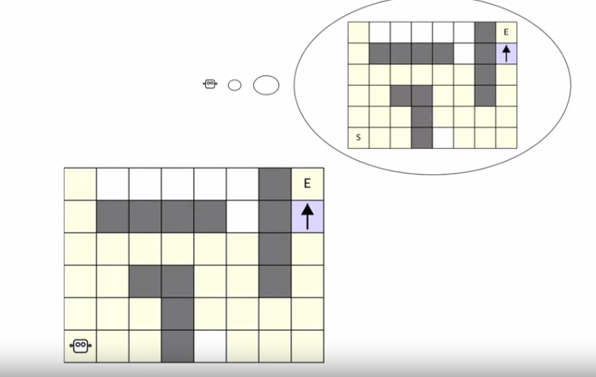
87. .
88. .
89. .
90. . The yellow states represent where the model knows what will happen next.
91. .
92. .
93. . The model knows about all the states the robot visited during the first episode.
94. .
95. Let's look what happens if we run the planning loop at the beginning of the second episode.
96. Dyna can simulate transitions from any of the state action pairs the agent visited during the first episode.
97. .
98. .
99. . 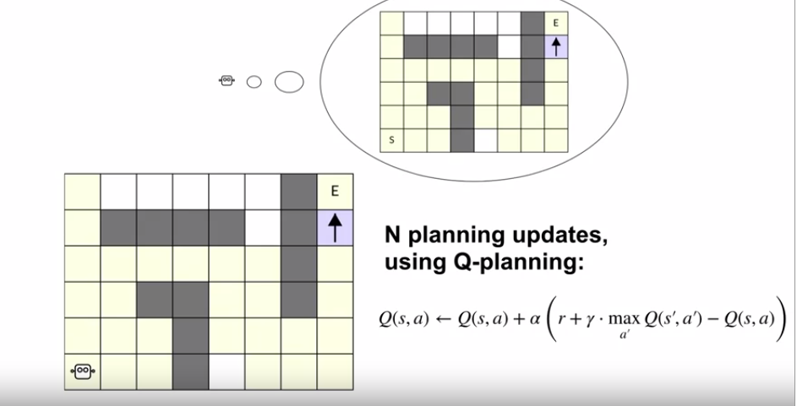
100. .
101. In this case, there are a lot of them. Planning replays the simulated transitions as if they happened in the real world.
102. Each step of planning simply applies the **Q-learning update to a simulated transition and updates the value function.**
103. .
104. .
105. .
106. .
107. . 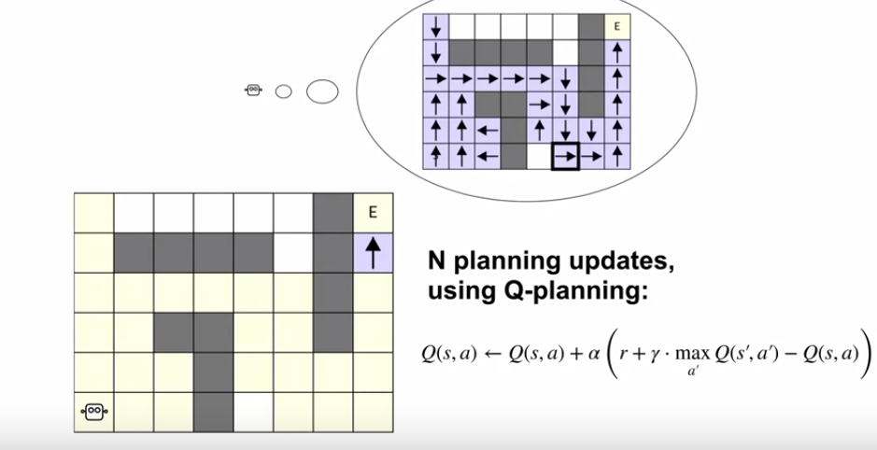
108. .
109. .
110. . With enough planning steps, the agent can approve the policy in all the states visited during the first episode.
111. Here, planning produce a pretty good policy. The policy is not perfect. Can you see where take suboptimal actions?
112. .
113. . 
114. .
115. .
116. .
117. . The policy is still random in states that were not visited before.
118. We represent these states for the policy was not updated with white squares.
119. .
120. Let's see how the plan policy works in the real world. The robot now knows how to get to the goal quickly after just one episode.
121. .
122. . 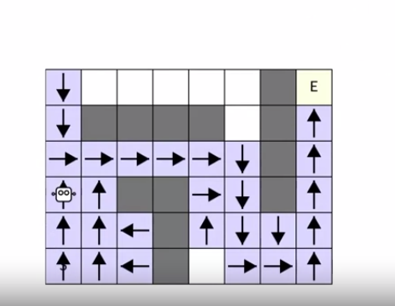 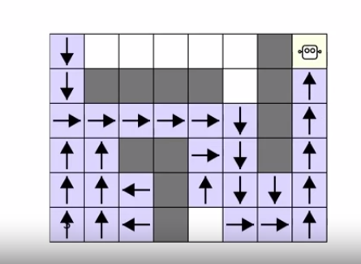
123. .
124. .
125. In comparison, Q-learning require many episodes to achieve similar performance. Dyna does more computation per step, but uses limited experience more efficiently.
126. .
127. Remember, this is only a cartoon. Dyna would act slightly differently than shown here.
128. .
129. The robot would continue exploring and planning on each step of the second episode.
130. So the policy would take random actions once in a while and the policy would continue to change, and improve due to planning. We will discuss how to implement Dyna the next time.
131. .
132. .
133. 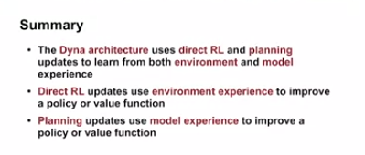
134. .
135. .
136. .
137. .
138. .
139. .
140. .
141. .
142. DYNA Q Algorithm
143. We discussed how Dyna unifies planning, learning, and acting.
144. This unification introduce some additional concepts like model learning and search control.
145. .Today we'll take a closer look at how all these pieces fit together. In this video, we will discuss a specific instance of the Dyna architecture called tabular Dyna-Q.
146. By the end of this video, you should be able to describe how Tabular Dinah-Q works.
147. .
148. .
149. . 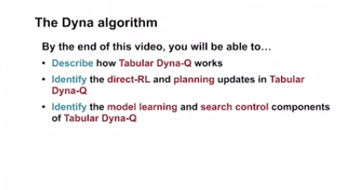
150. .
151. You will also be able to identify the direct-RL, planning, model learning, and search control parts of Dyna-Q.
152. .
153. Let's first discuss how Tabular Dyna-Q algorithm learns a model. Tabular Dyna -Q assumes deterministic transitions. .see below
154. .
155. .
156. 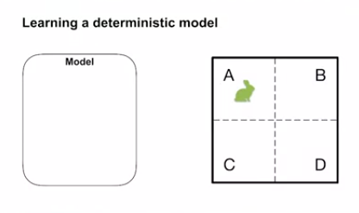
157. .
158. For example, when this rabbit chooses to move right in state A, there's only one outcome. see below
159. .
160. . 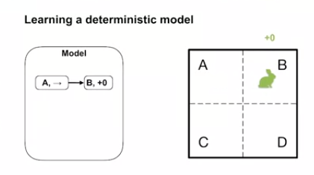
161. .
162. .
163. .
164. The rabbit transitions to state B with a reward of zero.
165. .
166. .
167. Likewise, if the rabbit moves right in state B, it stays in state B with a reward of one.
168. .
169. .
170. . 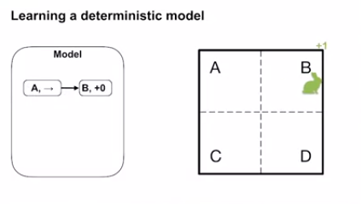 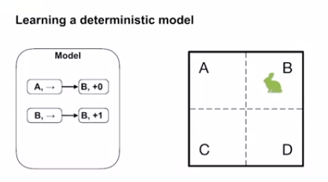
171. .
172. .
173. The left action in B always takes the rabbit to state A with a reward of zero.
174. .
175. . 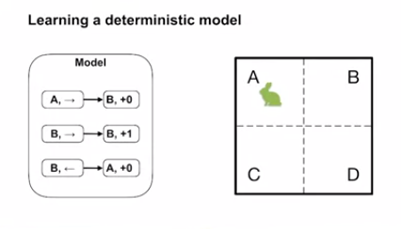
176. .
177. .
178. After the rabbit has experienced these transitions, the model knows what happens in these state action pairs. If a transition occurred once, it will always unfold that way in the future. The model can be certain about this.
179. .
180. .
181. .
182. .
183. Let's look at the Dyna-Q algorithm in detail.
184. .
185. First, we have the usual agent environment interaction loop.
186. 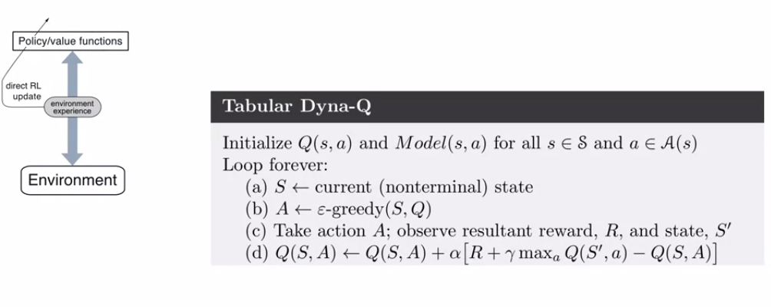
187. .
188. In the current state, the agent selects an action according to its epsilon greedy policy.
189. It then observes the resulting reward in next state.
190. .
191. .
192. It performs a Q-learning update with this transition, what we call direct-RL.
193. .
194. If we were to stop here, we would get exactly the Q-learning algorithm.
195. .
196. This is where things start to differ from model-free methods.
197. .
198. .
199. Dyna-Q will take this transition and perform a model learning step with it.
200. To do so, the algorithm memorizes the next state and reward for the given state action pair.
201. .
202. .
203. . 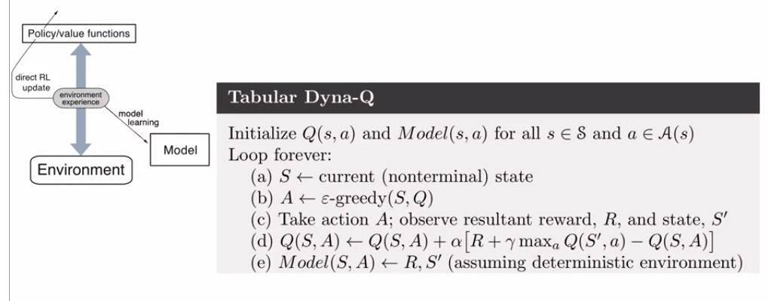
204. This works because we assume the environment is deterministic.
205. .
206. Dyna-Q then performs several steps of planning.
207. .
208. .
209. 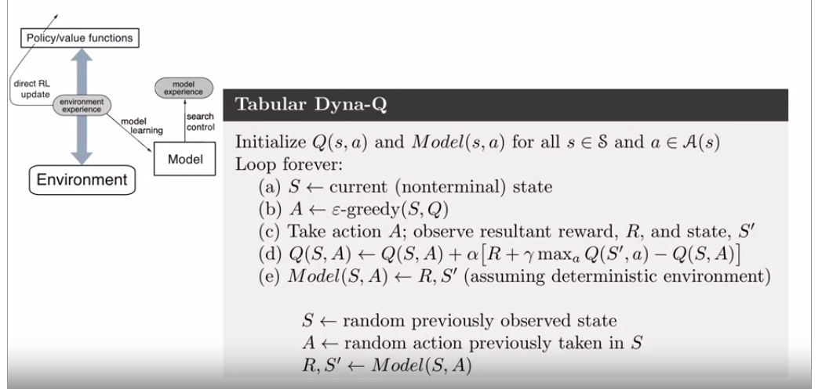
210. .
211. .
212. Each planning step consists of three steps; search control, model query, and value update.
213. . 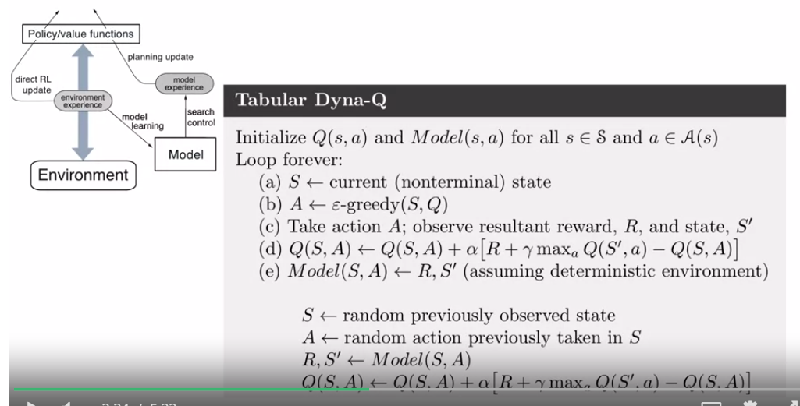
214. .
215. .
216. .
217. In this algorithm, search controls selects a previously visited state action pair at random.
218. It must be a state action pair the agent has seen before.
219. Otherwise, the model would not know what happens next.
220. .
221. Given the state action pair, we create the model for the next state and reward. We have now generated a model transition.
222. .
223. Finally, Dyna-Q performs a Q-learning update with the simulated transition.
224. .
225. The planning step is repeated many times.
226. .
227. .
228. . 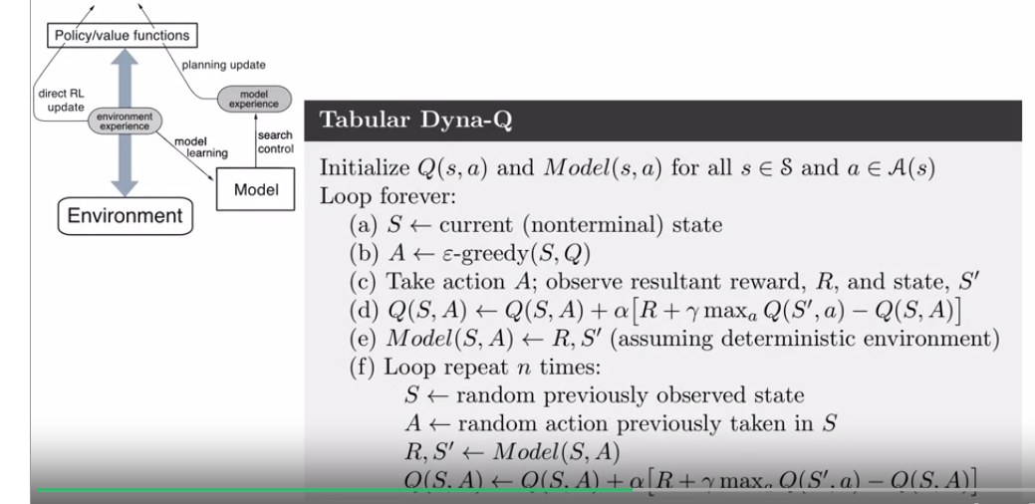
229. .
230. The most important thing to remember is that Dyna-Q performs many planning updates for each environment transition.
231. .
232. .
233. .
234. .
235. .
236. That's tabular Dyna-Q, a simple instance of the Dyna architecture. Let's revisit our robot friend to better understand the Dyna-Q algorithm.
237. .
238. . 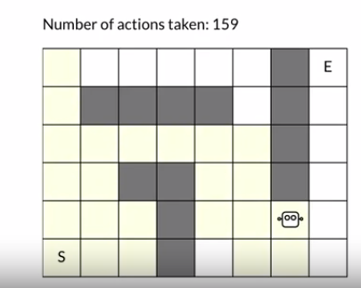 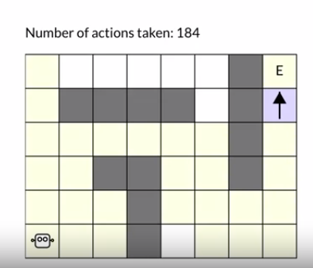
239. .
240. Remember, this is just a cartoon to build intuition. Like before, it starts out knowing nothing about the environment.
241. .
242. The robot gradually builds a model while interacting with the environment.
243. The first episode takes a 184 steps. In that time, the agent only change the value of the state action pair beside the goal.
244. .
245. .
246. Without planning, the next few episodes would probably be just as long.
247. .
248. Let's look at the next episode and study the impact of doing 100 steps of planning on every time step.
249. .
250. .
251. .
252. The last time we talked about this robot, it was doing way more planning on each step. So this time around, it will take longer for Dyna-Q to find a good policy.
253. .
254. . 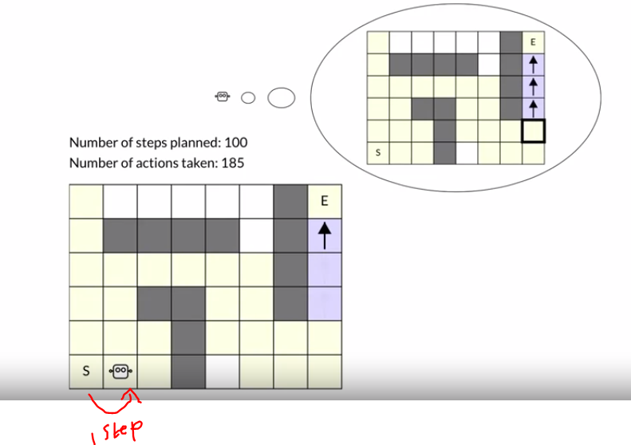
255. .
256. .
257. .
258. .
259. .
260. After just one step, planning updated the values of two more states. Now, the agent knows the correct actions in the final corridor.
261. 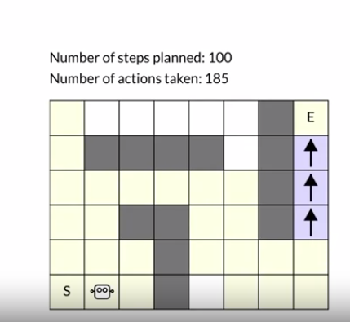
262. .
263. .
264. Let's run Dyna-Q a bit longer.
265. .
266. .
267. . 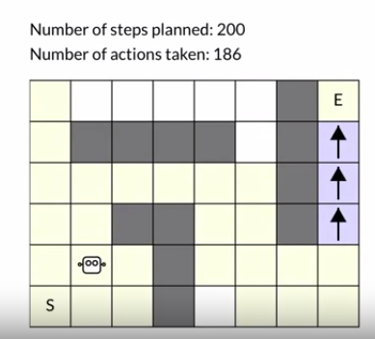 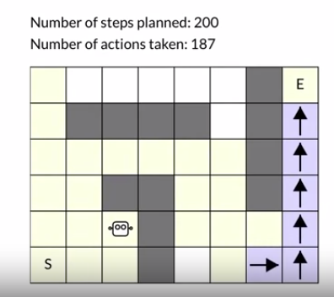
268. .
269. .
270. .
271. .
272. 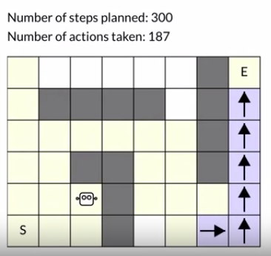. 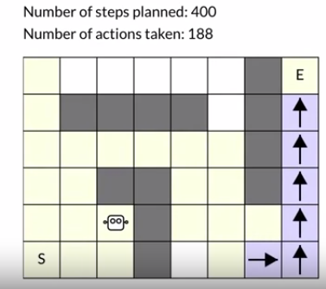
273. .
274. .
275. .
276. .
277. .
278. . 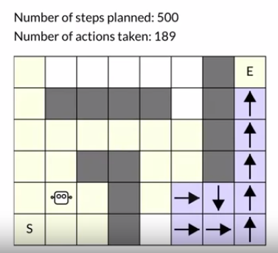 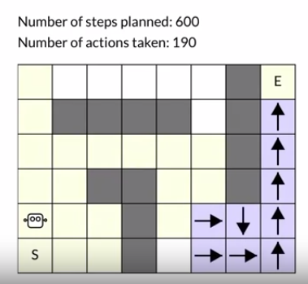
279. .
280. .
281. 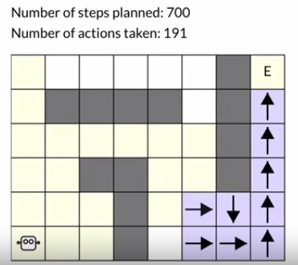 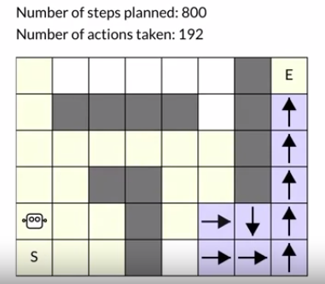
282. .
283. .
284. .
285. 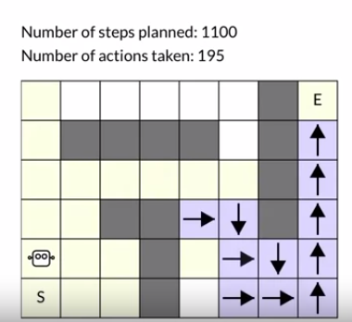 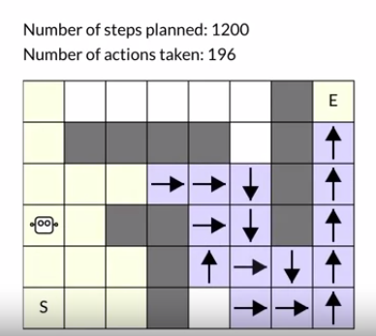
286. .
287. .
288. .
289. .
290. .
291. The impact of planning is quite dramatic. Dyna-Q propagates the reward information across the entire state space. Eventually, the agent knows an effective policy for navigating to the goal from most states.
292. .
293. .
294. . 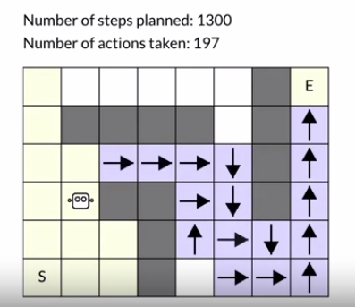 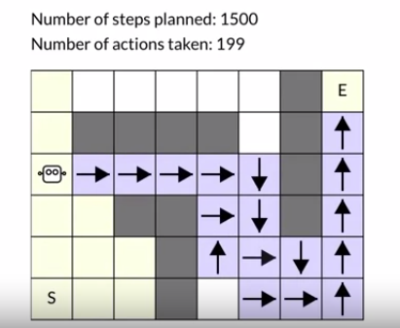
295. .
296. 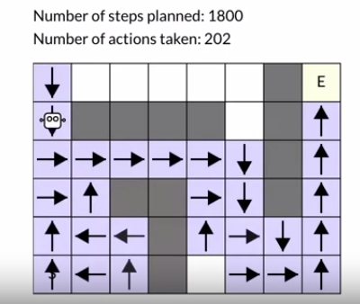 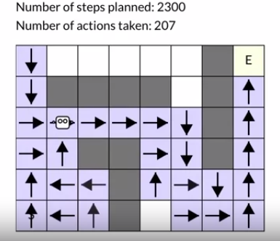
297. .
298. .
299. 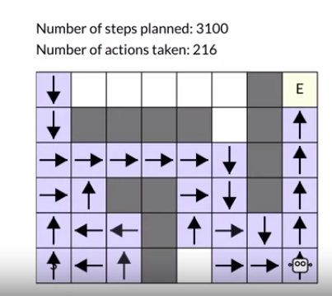 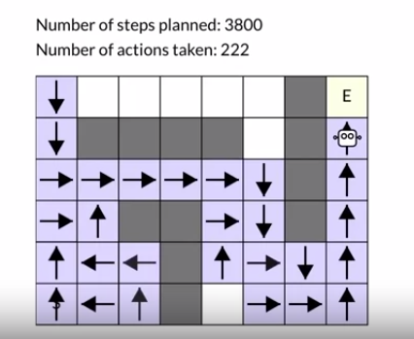
300. 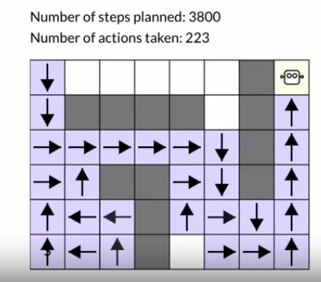
301. .
302. .
303. .
304. The policy computed by planning only requires 18 steps to reach the goal.
305. .
306. .
307. After just two episodes, that's more than ten times shorter than the first episode.
308. Tabular Dyna-Q performed many more updates to the value function than it would have without planning.
309. Dyna-Q makes better use of its limited interaction with the environment.
310. .
311. In this video, we learned how Tabular Dyna-Q mixes planning, learning, and acting through the value function. We also studied how Dyna-Q updates it's value function in a small Gridworld.
312. .
313. .
314. .
315. .
316. 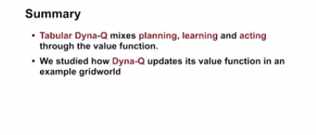
317. .
318. .
319. .
320. .
321. .
322. .
323. .
324. we've discussed the Dyna architecture and how it combines planning, learning and acting. We've also studied how Dyna-Q operates in a grid world. Let's get down to business and run some experiments to see how well Dyna-Q really works.
325. .
326. .
327. . In this video you will use a small grid world to compare tabular Dyna-Q and model free Q-learning.
328. .
329. .
330. 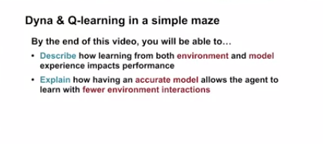
331. .
332. .
333. Today, we will run some experiments on this small maze environment. Like before, the agent has four actions. Transitioning into the goal state generates a reward of +1. All other transitions generate a reward of 0.
334. .
335. .
336. .
337. . 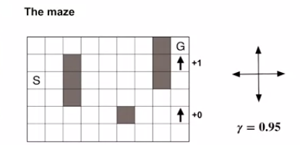
338. This problem is episodic and we will use a discount of 0.95.
339. .
340. Let's compare Dyna-Q with different amounts of planning. We will compare three agents. Each one will use alpha equal to 0.1 and epsilon equal to 0.1.
341. .
342. We initialize the action value estimates to 0 for all three agents. We run the experiment for 50 episodes 30 times and then average the results. Let's have a look.
343. We can plot the average number of steps the agent took to complete each episode after more and more episodes. If the agent is doing well, then the number of steps should decrease with more episodes.
344. .
345. .
346. .
347. 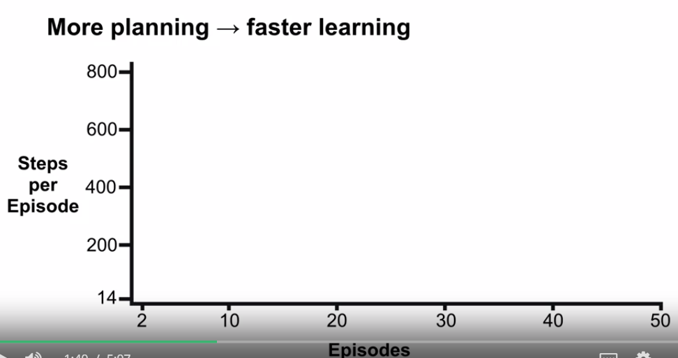
348. .
349. .
350. .
351. That is, lower on the y-axis is better.
352. If we run Dyna-Q with 0 planning steps we get exactly the Q-learning algorithm.
353. .
354. .
355. . 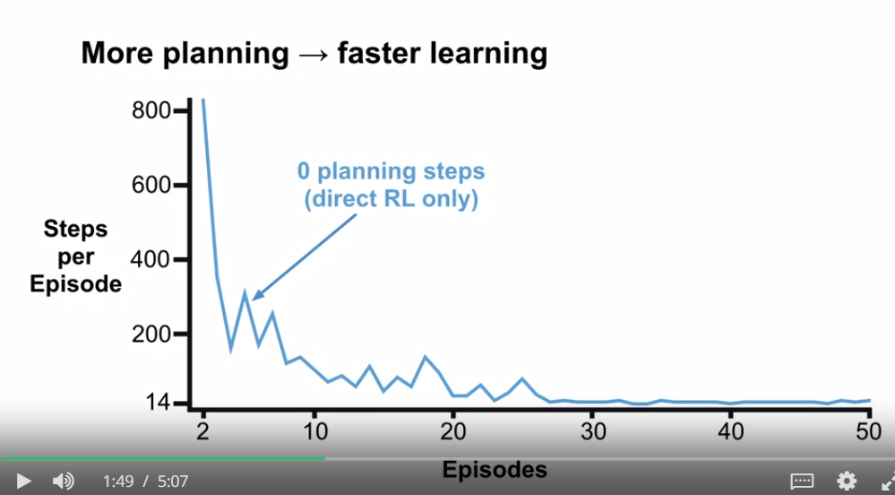
356. .
357. As we can see, it slowly gets better but plateaus at around 14 steps per episode. If we run Dyna-Q with five planning steps it reaches the same performance as Q-learning but much more quickly. See below
358. .
359. 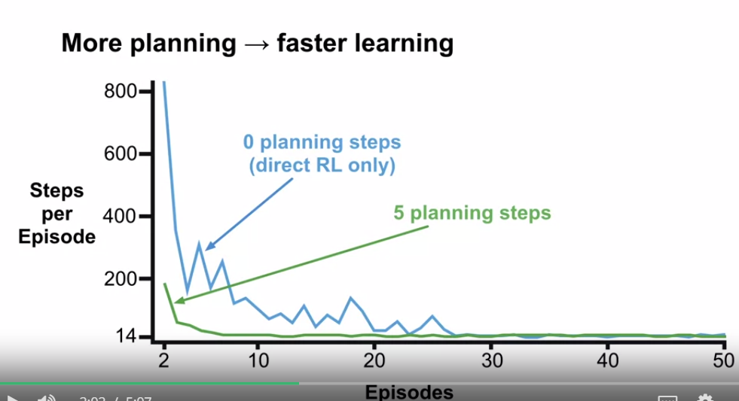
360. .
361. .
362. .
363. Dyna-Q with 50 planning steps only takes about three episodes to find a good policy.
364. .
365. .
366. . 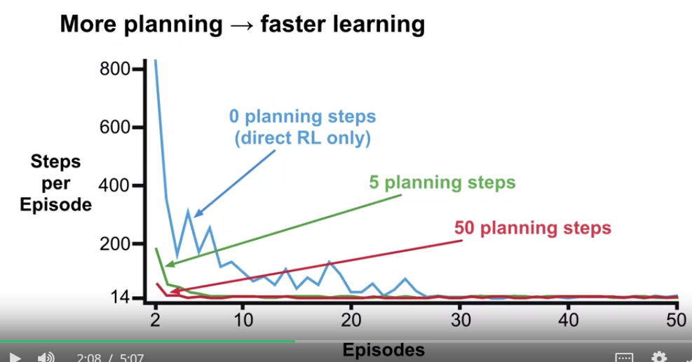
367. .
368. .
369. .
370. Dyna-Q is far more sample efficient.
371. .
372. Look at the y-axis. After two episodes the policy found by Q-learning still requires hundreds of steps to escape the maze.
373. .
374. For the same number of environment interactions, Dyna-Q can learn a lot more. This shows how planning makes better use of environment experience if the model is correct.
375. .
376. .
377. .
378. Let's visualize what's going on in a slightly different maze.
379. .
380. . 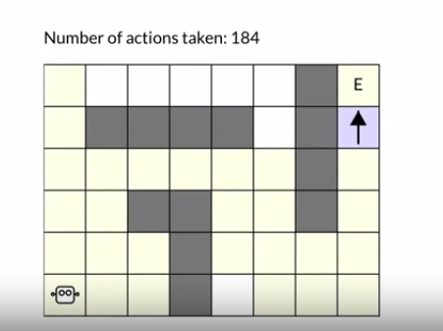
381. .
382. .
383. We use an arrow to show the greedy action according to the estimated value in each state.
384. A state without an arrow means that every action is equally likely under the policy.
385. .
386. After one episode, Q-learning updates just one action value, the one corresponding to the up action in the state next to the goal.
387. .
388. . 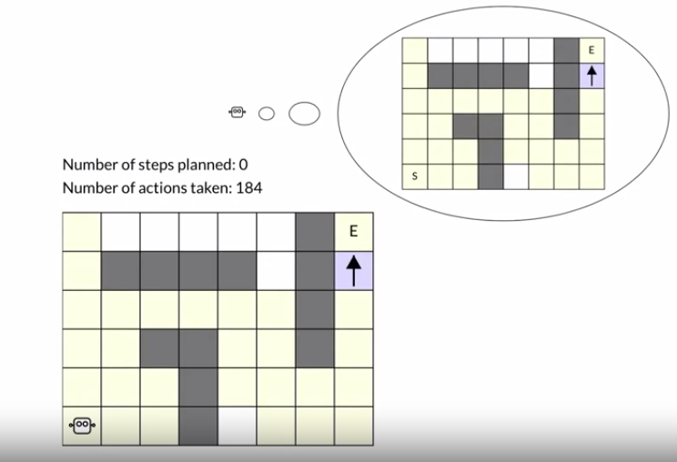
389. .
390. .
391. .
392. This is the only state where a transition with a nonzero reward was experienced.
393. .
394. .
395. . It would take several more episodes to bootstrap this state's value back to other nearby states.
396. .
397. .
398. .
399. Let's look more closely at how search control impacts planning. Our robot will do things slightly differently than Dyna-Q.
400. .
401. .
402. But that's just to emphasize our point more clearly. We will start with 10 planning steps and call the planning loop 10 times in a row, so that's 100 steps of planning in total.
403. .
404. .
405. . 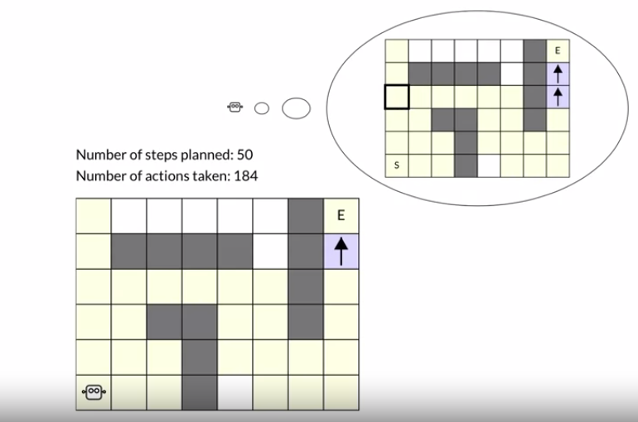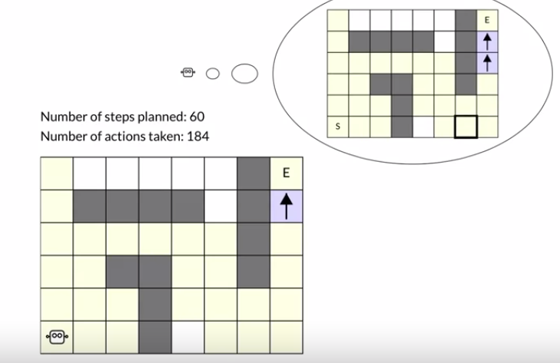
406. .
407. .
408. As you can see, many of the planning updates fail to change the value function. In fact, the agent only updated the values of 2 state action pairs after 100 steps of planning.
409. .
410. .
411. 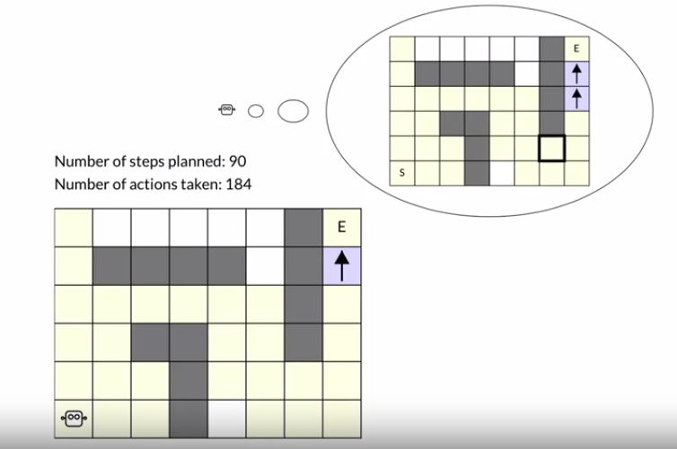
412. .
413. .
414. .
415. Let's keep going. This time we will try 100 planning steps per call and let the agent run a bit longer.
416. .
417. Even with 100 planning steps, the first few calls update only a handful of action values. Why does the agent needs so many planning steps to learn the value function and a reasonable policy?.
418. .
419. .
420. .
421. The agent needs many planning steps because search control samples state action pairs randomly.
422. .
423. The planning update will not have any effect if the sample state action pair produces a 0 T error.
424. .
425. .
426. .
427. . 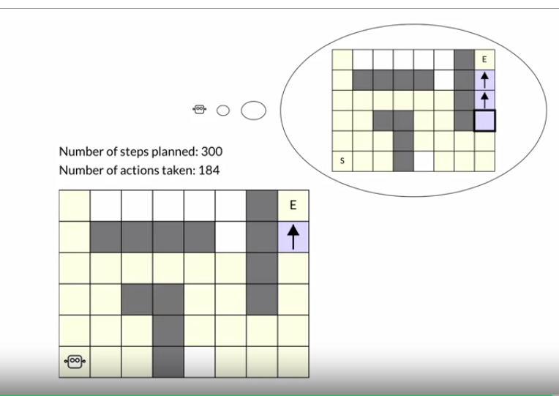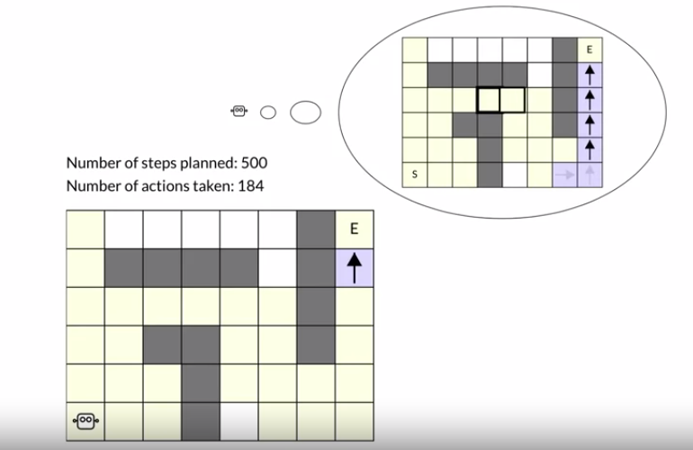
428. .
429. 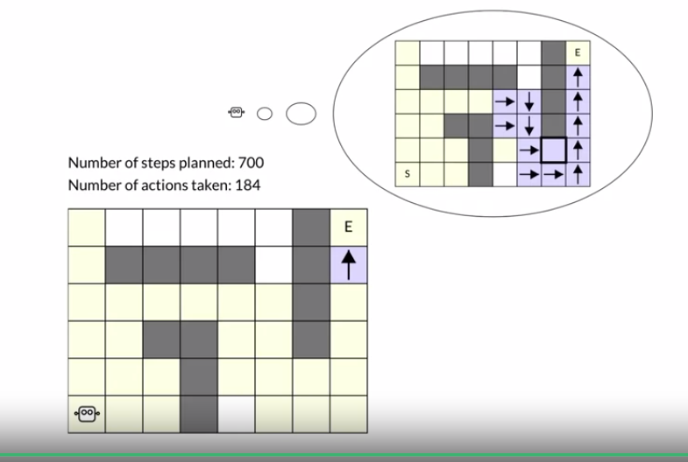
430. This happened a lot in this environment because all the rewards are 0, and so are the initial values.
431. .
432. What would happen if we ordered the state action pairs in a more efficient way?
433. It turns out the agent could learn a good policy only using a sixth of the planning updates
434. .
435. .
436. .
437. in larger environments random search control becomes even more problematic. If you want to learn more about this topic, check out section 8.4 of the textbook. [SOUND] In this video we tested the tabular Dyna-Q algorithm in a simple grid world. We saw how planning can dramatically speed up learning. In our experiment, the more planning we did the better the agent performed. Bye for now.
438. .
439. .
440. .
441. 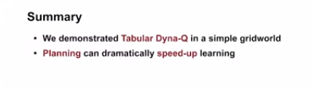
442. .
443. .
444. .
445. .
446. .
447. .
448. .
449. .
450. So far in the course, we've talked about how agents can improve their policies or value functions by planning with experience generated from a model.
451. .
452. But what happens if the agent plans with experience from an inaccurate model?
453. .
454. In this video, you will learn how to identify ways in which models can be inaccurate, explain the effects of planning with an inaccurate model, and describe how Dyna implants successfully with an incomplete model.
455. .
456. .
457. . 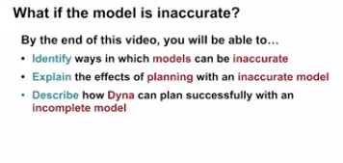
458. .
459. First, let's talk about what it means for a model to be inaccurate.
460. .
461. Models are inaccurate when transitions they store are different from transitions that happen in the environment.
462. .
463. .
464. . 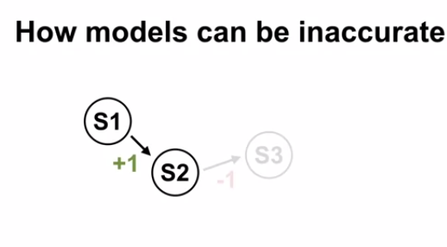
465. At the beginning of learning, the agent hasn't tried most of the actions in almost all of the states.
466. The transitions associated with trying those actions in those states are simply missing from the model.
467. .
468. .
469. . 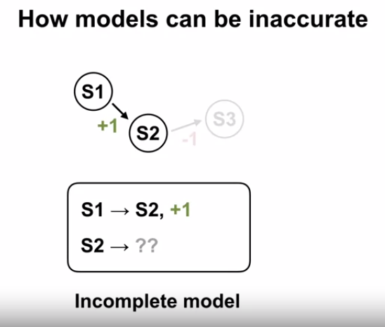
470. .
471. .
472. We call models of missing transitions incomplete models.
473. The model could also be an accurate if the environment changes.
474. Taking an action in a state could result in a different next state and reward than what the agent observed before the change.
475. .
476. . 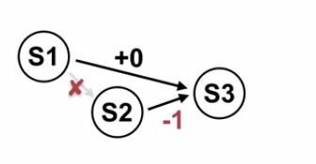
477. .
478. . We say the model is inaccurate because what actually happens is different from what the model says.
479. .
480. . 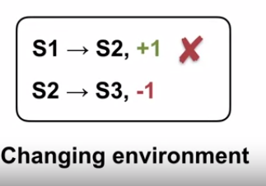
481. .
482. So what happens when we plan with inaccurate models? The effect of planning with inaccurate models depends on how the model is inaccurate. In the beginning, the model is incomplete.
483. . 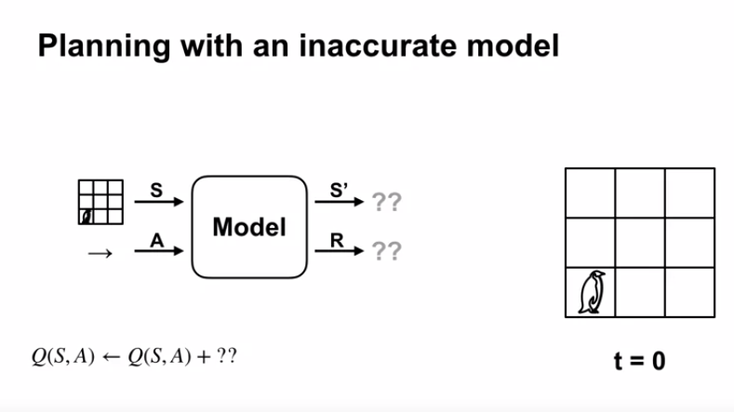
484. .
485. Since the model can't produce a next step or a reward, it can't be used for planning. However, as the agent interacts with the environment, the model stores more and more transitions. Then, the agent can perform updates by simulating transitions it's seen before.
486. .
487. . 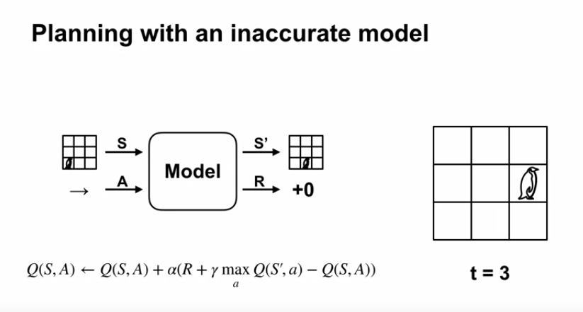
488. .
489. That means that as long as the agent has seen some transitions, it can plan with the model.
490. .
491. Now let's think about how changes in the environment affect planning. Imagine that the agent has already visited every state action pair and stored its experience in the model. Then, the environment changes.
492. .
493. . 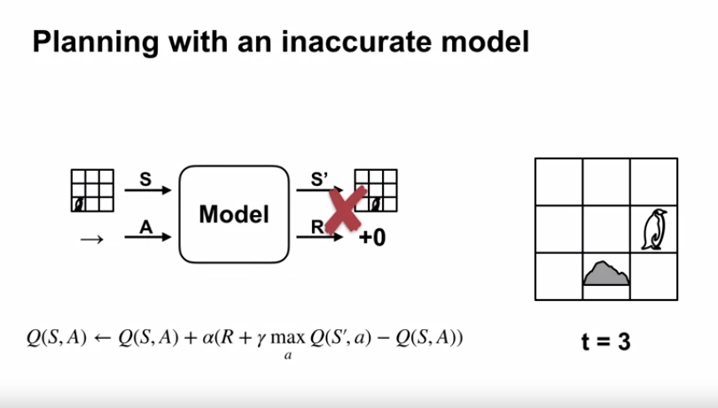
494. .
495. A transition in the model no longer reflects the transition in the environment. What will happen when the agent tries to plan using its inaccurate model?
496. .
497. If the agent tries to perform a planning update with one of the incorrect transitions in the model, the value function or policy that the agent updates might change in the wrong direction.
498. .
499. Remember that planning improves the policy with respect to what the model thinks will happen, rather than what will really happen in the environment.
500. .
501. The model becomes outdated when the environment changes.
502. .
503. Planning with that model will likely make the agent's policy worse with respect to the environment.
504. .
505. Now that we've gone over the two main ways that models can be inaccurate, let's think about how agents could plan successfully with incomplete models.
506. .
507. We've actually gone over one such algorithm already, Dyna queue.
508. Let's see how Dyna queue does planning with an incomplete model.
509. .
510. .
511. .
512. In the planning step, we must determine which state action pairs to query the model with.
513. .
514. . 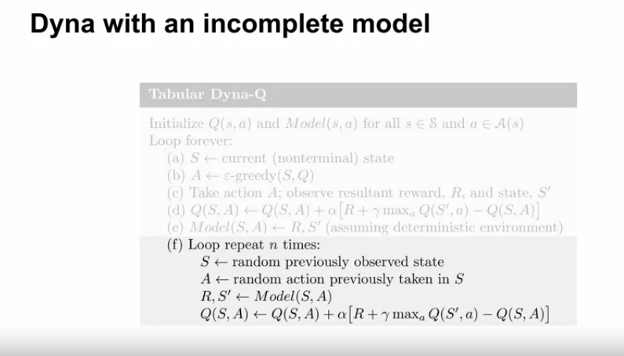
515. .
516. The model only knows the next state and reward from state action pairs it has already visited. Therefore, Dyna queue can only do planning updates from previously visited state action pairs.
517. .
518. Dyna queue only plans the transitions it has already seen. So, in the first few time steps of learning, Dyna queue might do quite a few planning updates with the same transition.
519. .
520. However, as Dyna queue visits more state action pairs in the environment, its planning updates become more evenly distributed throughout the state action space.
521. .
522. .
523. In this video, we talked about how models can be inaccurate if they are either incomplete or if the environment changes. Planning with an inaccurate model improves the policy or value function with respect to the model and not the environment. Dyna queue can plan with an incomplete model by only sampling state action pairs that had been previously visited. See you next time.
524. .
525. .
526. 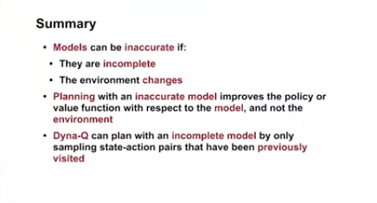
527. .
528. .
529. .
530. .
531. We previously talked about how agents can plan with models that are incomplete.
532. .
533. Now, let's discuss how agents can plan with models that are inaccurate because of changes in the environment.
534. .
535. By the end of this video, you'll be able to; explain how model inaccuracies produce another exploration-exploitation trade-off, and describe how Dyna-Q addresses this trade-off.
536. .
537. . 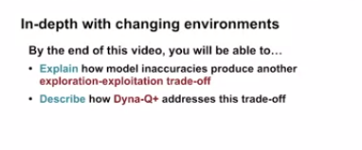
538. .
539. When the agents model is inaccurate, planning will likely make the policy or value function worse with respect to the environment.
540. . 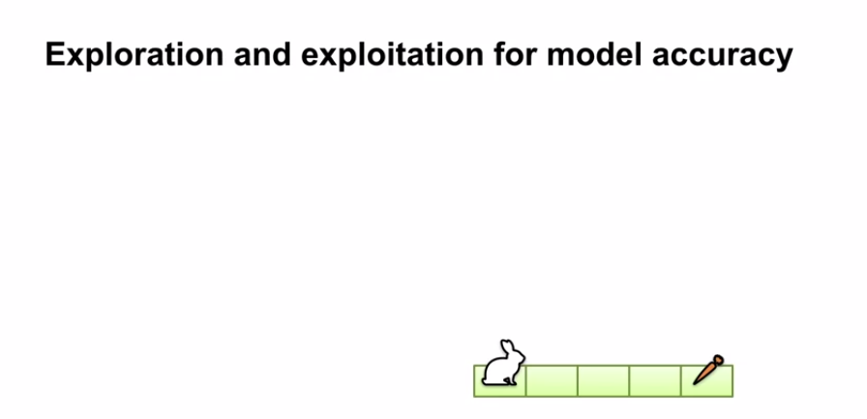
541. That means the agent has a vested interest in making sure it's model stays accurate.
542. .
543. In this example, the robust model initially says that the rabbit will go directly to the carrot if it chooses the move right.
544. .
545. .
546. . 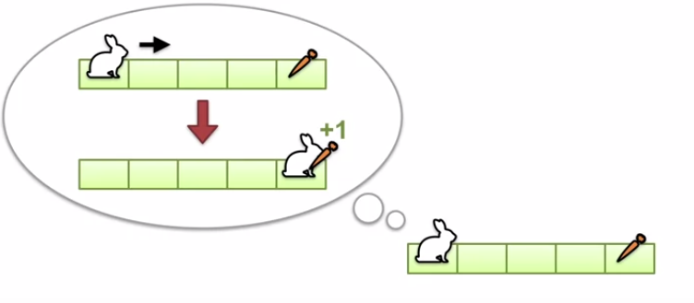
547. .
548. .
549. However, after moving right, the rabbit finds itself in the middle square.
550. After experiencing this transition, the rabbit can update its model of the world.
551. .
552. .
553. . 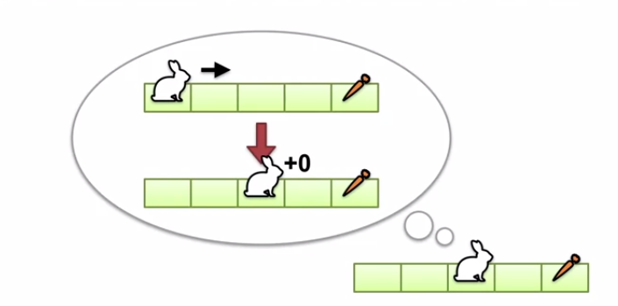
554. .
555. The update reflects that choosing the move right action, in the leftmost square, will result in moving to the middle square.
556. .
557. .
558. We saw that the rabid corrected its model after experiencing a transition in the environment.
559. .
560. In general, an agent might want to double-check that all its models transitions are correct.
561. However, double-checking transitions with low valued actions will often lead to low reward.
562. .
563. In changing environments, the agent's model might become inaccurate at any time. So the agent has to make a choice;
564. explorer to make sure it's model is accurate, or exploit the model to compute the optimal policy, assuming that the model is correct.
565. .
566. When the environment changes, the model will be incorrect.
567. .
568. It will remain incorrect until the agent revisits that part of the environment that changed and updates the model.
569. .
570. .
571. This suggests that the agent should explore places it has not been to in a while.
572. .
573. Let's think about how that might work. Roughly speaking, the model is more likely to be wrong and states the agent has not visited in a long time.
574. .
575. .
576. For example, let say the rabbit knows the turtle starts in the following cell.
577. .
578. . 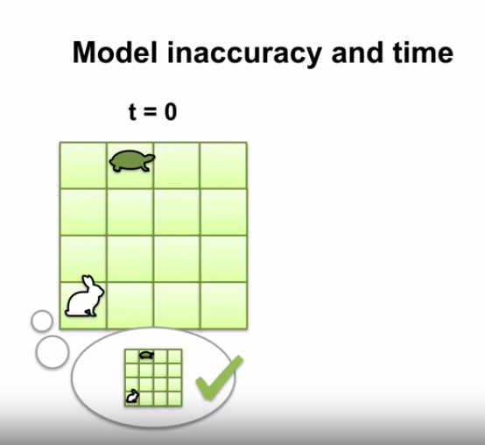
579. .
580. .
581. Since the turtle moves slowly, it can't move very far in the first few time-steps. However, after a long time, the turtle might be in a totally different cell than it started in, making the rabbits model incorrect.
582. .
583. . 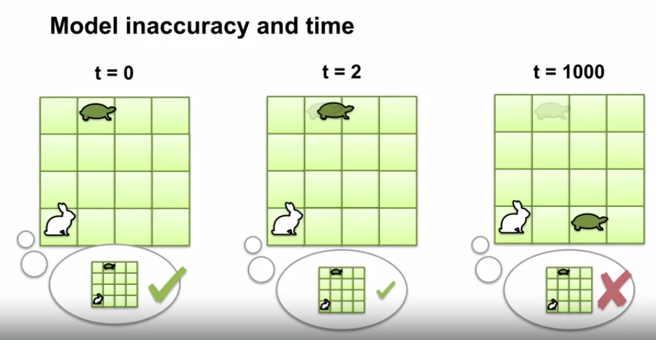
584. .
585. .
586. .
587. To encourage the agent to revisit its state periodically, we can add a bonus to the reward used in planning.
588. .
589. . 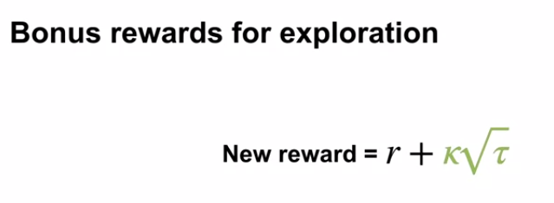
590. .
591. .
593. This bonus is simply Kappa, times the square root of Tau, where r, is the reward from the model and Tau is the amount of time it's been since the state action pair was last visited in the environment.
594. .
595. .
596. .
597. . 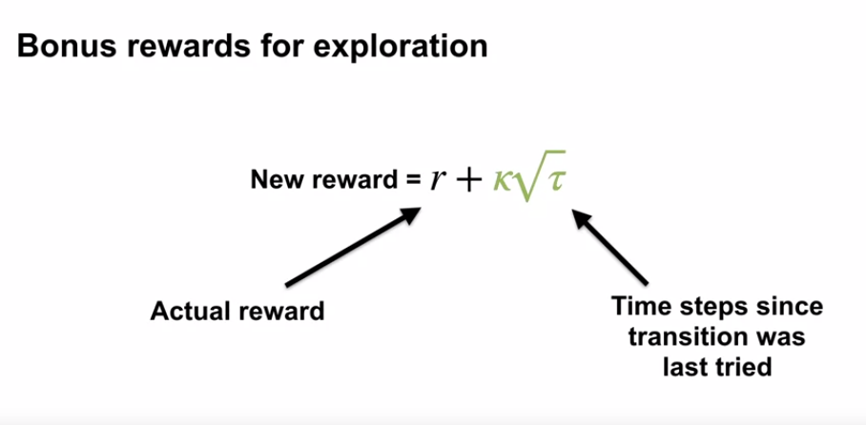
598. Tau is not updated in the planning loop, that would not be a real visit.
599. Kappa is a small constant that controls the influence of the bonus on the planning update. If Kappa was zero, we would ignore the bonus completely.
600. .
601. . 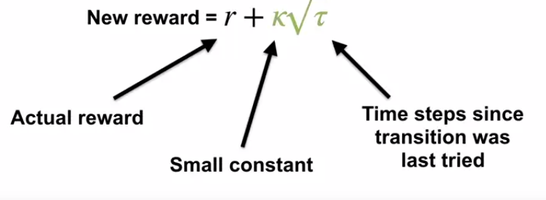
602. .
603. .
604. Adding this exploration bonus to the planning updates results in the Dyna-Q+ algorithm.
605. .
606. . 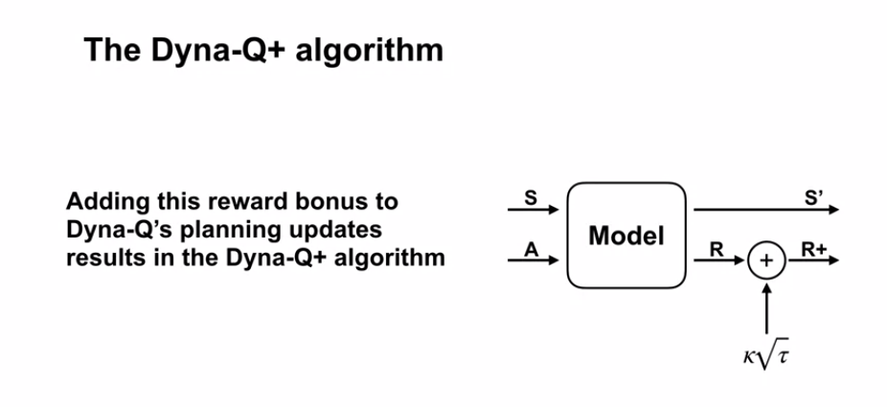
607. .
608. By artificially increasing the rewards used in planning, we increase the value of state action pairs it haven't been visited recently.
609. How exactly does this encourage exploration?
610. Imagine a state action pair essay that has not been visited in a long time. That means the Tau will be large.
611. .
612. As Tau grows, the bonus becomes bigger and bigger. Eventually, planning will change the policy to go directly to S due to the large bonus.
613. .
614. .
615. When the agent finally visit state S, it might see a big reward, or it might be disappointed.
616. Either way, the model will be updated to reflect the dynamics of the environment.
617. .
618. .
619. .
620. Let's look at the shortcut maze to understand the difference between Dyna-Q and Dyna-Q+.
621. . 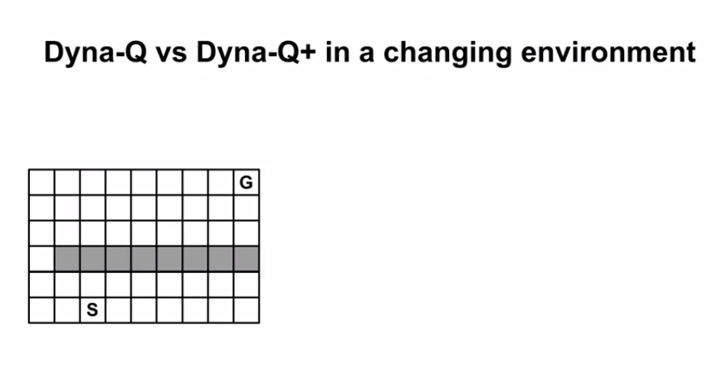
622. In this example, the objective is to get to the goal from the start state as fast as possible. The rewards are zero everywhere, except for the terminal transition, which emits a reward of plus one. The discount factor is less than one because we want to encourage the agent to reach the goal quickly.
623. .
624. Both Dyna-Q and Dyna-Q+ use epsilon-greedy action selection.
625. .
626. For the first half of the experiment, Dyna-Q and Dyna-Q+ behave very similarly.
627. .
628. . 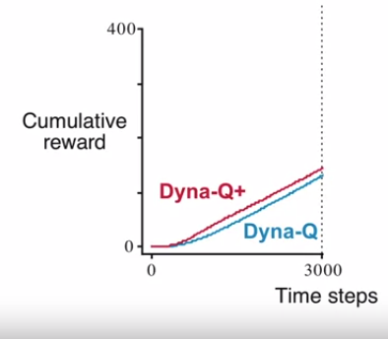
629. .
630. In this case, the increased exploration by Dyna-Q+ helps define a good policy more quickly. That is why Dyna-Q+ line is above the Dyna-Q+ line.
631. .
632. Now, we create a shortcut on the right side of the wall.
633. .
634. . 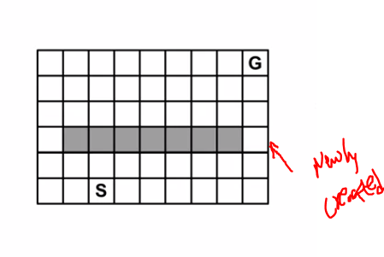
635. .
636. Let's see how Dyna-Q and Dyna-Q+ adapt to that change. Can they find the shorter path to the goal through the right side of the wall? Here are the results, Dyna-Q+ finds a shortcut soon after the environment changes, Dyna-Q on the other hand, does not find the shortcut in the time allotted.
637. .
638. .
639. . 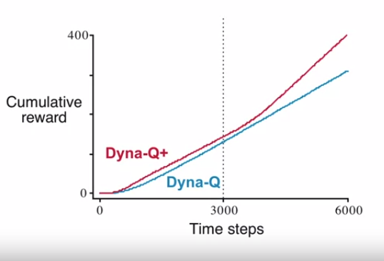
640. .
641. .
642. Eventually, Dyna-Q will find the shortcut by re-exploring the entire state action space using epsilon-greedy.
643. However, doing so would require at least seven exploratory actions in a row. So it could take a very long time.
644. .
645. In this environment, the persistent and systematic exploration of Dyna-Q+ was key.
646. .
647. .
648. In this video, we talked about how; model accuracy produces a new variant of the exploration-exploitation trade-off. The agent has to explore to make sure it's model is accurate. We also talked about how Dyna-Q+ uses expiration bonuses to explore the environment.
649. .
650. .
651. 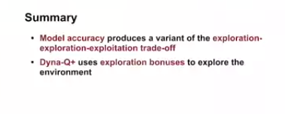
652. .
653. .
654. .
655. 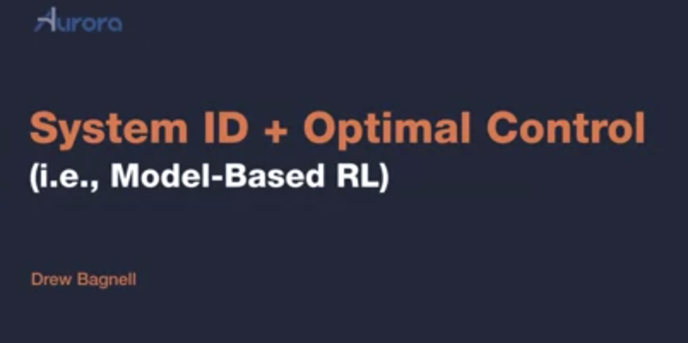
656. .
657. .
658. 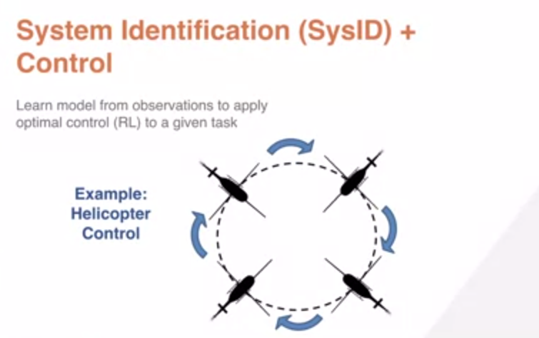
659. .
660. 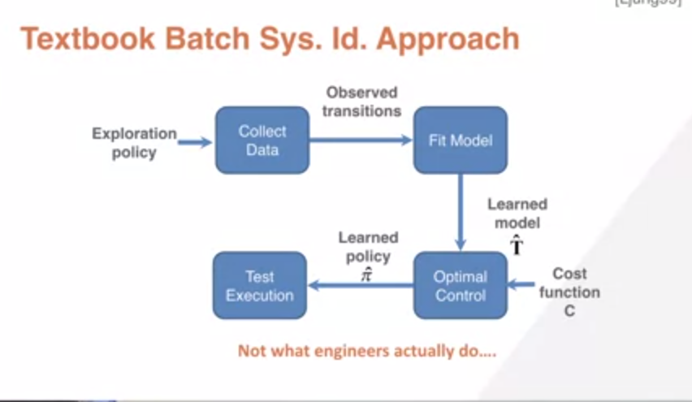
661. .
662. The traditional view of this is known as system identification. It's taught in engineering statistics as essentially a supervised learning approach. We have some way of collecting data using exploration policy. For instance, for a pilot who controls the helicopter and induces deviations in those controls to explore the space of states. We then take that observed data and we apply a supervised learning algorithm. Imagine, for instance, applying linear regression. Given that supervised learning the algorithm and the data, we're learning a model here called T-hat which maps states and actions to next dates. We take that model. We take a cost function. We combine them together using planning or optimal control synthesis algorithms, reinforcement learning algorithms, if you will and we output a learned policy, which is hopefully optimal in the actual world. In practice, what we find is this is not actually what good engineers do. Instead, they tend to take an iterative approach to building the model. Let's see why. In this example, we begin by collecting data from expert demonstration of this nose and fall and we collect a variety of examples of it doing this task. Then we apply the class of optimal control algorithms we talked about in the last lecture to try to generate a policy. What you find is unfortunately, it fails pretty spectacularly.
663. .
664. 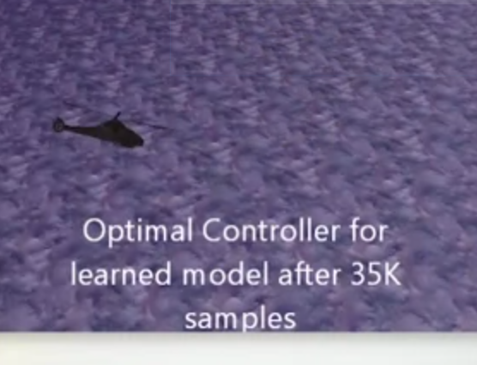
665. .
666. Now, why does this go wrong? Well fundamentally, the problem of system identification is really a chicken or the egg problem. We really want to learn a model that's good where the RL algorithm or optimal control synthesis algorithm is likely to visit as it learns a policy. Unfortunately, if we learn them all and then plan or optimize against, it will almost certainly visit states in the process where the model was inaccurate. That were undersampled during data collection procedure. And then the RL algorithm can find any way to exploit that inaccuracy and learn a policy that doesn't perform well because the real world doesn't match the model in those states. This general problem is sometimes known as covariate or distributional shift and its really a fundamental problem whenever we blend statistical learning with decision-making. The result is both in theory and practice, you can build statistical models that are dynamics with very low error, apply a good Optimizer or RL algorithm to that model and still get bad performance in the real world. That's really a bummer.
667. .
668. 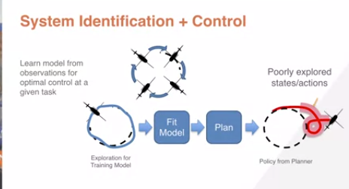
669. .
670. .
671. I find a really useful way to think about model-based reinforcement learning is as a two-player game between the optimizer and RL algorithm and the model learning and the world together. As I learned years ago from Chris Atkinson, the best way to find an inaccuracy in your simulator is to let an RL algorithm try to exploit it, to find a loophole in your model, a glitch in The Matrix if you will. We thus need approaches that are more robust and fundamentally interactive to find good models and good controllers.
672. .
673. . 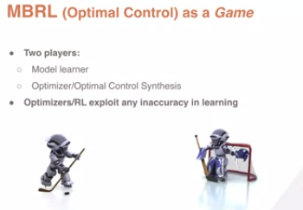
674. .
675. I'll take you through an approach here, which is fundamentally interactive. The idea is that we will collect data from our purported current optimal policy as well as that exploration policy I described before.
676. We'll get transitions that describe the way the helicopter goes from a state, takes an action and goes to the next state. We'll aggregate that together with all the previous transitions that we've had. Again, this is an iterative algorithm.
677. .
678. . 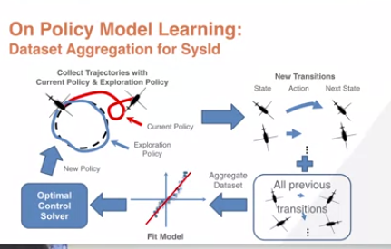
679. .
680. We'll fit them all. Again, I'm showing here fitting linear regression. Then we'll hand this off to an optimal control synthesis approach or a planner or reinforcement learning algorithm, if you will. And the result will be a new policy, a new purported optimal policy. And then we run this loop again, collecting data from the new policy together mixed with some data from the exploration policy.
681. .
682. .
683. .
684. 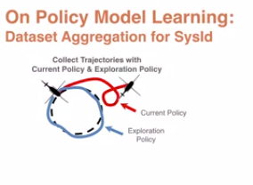
685. .
686. .
687. .
688. .
689. . All of those transitions are aggregated together with everything we've previously seen before. We fit them all, hand it off to the synthesis which hands back up reported new policy and continue in this loop. It turns out if you run this loop, Stefan Roth demonstrated that this kind of interactive approach which turns out to much more closely match the style used by expert engineers works really well in practice and it can provide stronger theoretical guarantees.
690. If you learn a low error model across iterations of interaction using a stable function approximator and you generate policies using a good optimal control solver, you must achieve good performance.
691. .
692. . 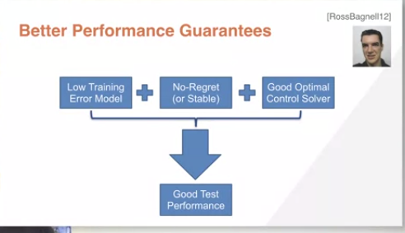
693. And put in the contrapositive to not get good real world performance using a No Regret learning algorithm, the class of algorithm we're talking about for learning. A good optimizer against that all. It must be the case that at some point you failed to build a low error model of how the world works. There's lots of details to these fiscal guarantees, but they indicate that stable learning and on policy model learning are probably on the right track.
694. .
695. .
696. .
697. .
698. I mentioned briefly this idea of no regret learning. It's a powerful concept worth learning about and it's very useful in any context which seems game-like. And you can simplify it in your head to the class of algorithms that don't change the model they return much in response to small perturbations in their training data and which achieve good performance in the limit of large data. Okay, we can take that same inverted or rather nose-in funnel problem I described before and apply this loop we described and here's the results.
699. .
700. .
701. 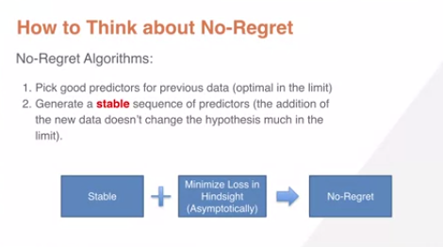
702. .
703. .
704. We'll collect the same number of samples using this data set aggregation approach
705. .
706. . 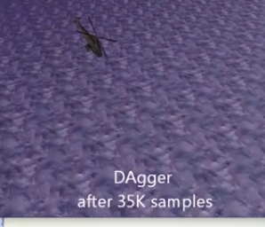
707. And in this case, we'll be able to actually solve the problem. So this is interesting.
708. .
709. The only thing that's different, same synthesis algorithm, same number of samples. All that's different is we've collected data in an interactive way where we've proposed optimal controllers. Tried them, collected more data and then rebuilt the model. And the result is we're successfully able to execute the nose-in funnel. I thank you for your attention. And I really hope these lectures give you a head start on ideas for applying models and reinforcement learning in the real world.
710. .
711. .
712. .
713. .
714. .
715. .
716. In the second lecture, I'll give you a quick introduction to the process of learning models within model-based reinforcement learning with an emphasis on approaches you might find practical. Okay, last time we discussed the key benefits of using a model, the ability to learn in simulation and thus greatly reduce the expense and time of real-world interaction. Of course the key to make that happen is we need the ability to learn a model. For the rest of this lecture, we're going to use as an example the problem of autonomous helicopter patrol. In this case, what's known as a nose-in funnel. And we want to learn a model from observations so that we can apply optimal control to, for instance, this given task.
717. .
718. The traditional view of this is known as system identification. It's taught in engineering statistics as essentially a supervised learning approach. We have some way of collecting data using exploration policy. For instance, for a pilot who controls the helicopter and induces deviations in those controls to explore the space of states. We then take that observed data and we apply a supervised learning algorithm. Imagine, for instance, applying linear regression. Given that supervised learning the algorithm and the data, we're learning a model here called T-hat which maps states and actions to next dates. We take that model. We take a cost function. We combine them together using planning or optimal control synthesis algorithms, reinforcement learning algorithms, if you will and we output a learned policy, which is hopefully optimal in the actual world. In practice, what we find is this is not actually what good engineers do. Instead, they tend to take an iterative approach to building the model. Let's see why. In this example, we begin by collecting data from expert demonstration of this nose and fall and we collect a variety of examples of it doing this task. Then we apply the class of optimal control algorithms we talked about in the last lecture to try to generate a policy. What you find is unfortunately, it fails pretty spectacularly.
719. .
720. Now, why does this go wrong? Well fundamentally, the problem of system identification is really a chicken or the egg problem. We really want to learn a model that's good where the RL algorithm or optimal control synthesis algorithm is likely to visit as it learns a policy. Unfortunately, if we learn them all and then plan or optimize against, it will almost certainly visit states in the process where the model was inaccurate. That were undersampled during data collection procedure. And then the RL algorithm can find any way to exploit that inaccuracy and learn a policy that doesn't perform well because the real world doesn't match the model in those states. This general problem is sometimes known as covariate or distributional shift and its really a fundamental problem whenever we blend statistical learning with decision-making. The result is both in theory and practice, you can build statistical models that are dynamics with very low error, apply a good Optimizer or RL algorithm to that model and still get bad performance in the real world. That's really a bummer.
721. .
722. I find a really useful way to think about model-based reinforcement learning is as a two-player game between the optimizer and RL algorithm and the model learning and the world together. As I learned years ago from Chris Atkinson, the best way to find an inaccuracy in your simulator is to let an RL algorithm try to exploit it, to find a loophole in your model, a glitch in The Matrix if you will. >> We thus need approaches that are more robust and fundamentally interactive to find good models and good controllers.
723. .
724. .
725. I'll take you through an approach here, which is fundamentally interactive. The idea is that we will collect data from our purported current optimal policy as well as that exploration policy I described before. We'll get transitions that describe the way the helicopter goes from a state, takes an action and goes to the next state. We'll aggregate that together with all the previous transitions that we've had. Again, this is an iterative algorithm. We'll fit them all. Again, I'm showing here fitting linear regression. Then we'll hand this off to an optimal control synthesis approach or a planner or reinforcement learning algorithm, if you will. And the result will be a new policy, a new purported optimal policy. And then we run this loop again, collecting data from the new policy together mixed with some data from the exploration policy.
726. .
727. All of those transitions are aggregated together with everything we've previously seen before. We fit them all, hand it off to the synthesis which hands back up reported new policy and continue in this loop. It turns out if you run this loop, Stefan Roth demonstrated that this kind of interactive approach which turns out to much more closely match the style used by expert engineers works really well in practice and it can provide stronger theoretical guarantees. If you learn a low error model across iterations of interaction using a stable function approximator and you generate policies using a good optimal control solver, you must achieve good performance. And put in the contrapositive to not get good real world performance using a No Regret learning algorithm, the class of algorithm we're talking about for learning. A good optimizer against that all. It must be the case that at some point you failed to build a low error model of how the world works. There's lots of details to these fiscal guarantees, but they indicate that stable learning and on policy model learning are probably on the right track.
728. .
729. .
730. I mentioned briefly this idea of no regret learning. It's a powerful concept worth learning about and it's very useful in any context which seems game-like. And you can simplify it in your head to the class of algorithms that don't change the model they return much in response to small perturbations in their training data and which achieve good performance in the limit of large data. Okay, we can take that same inverted or rather nose-in funnel problem I described before and apply this loop we described and here's the results.
731. .
732. .
733. We'll collect the same number of samples using this data set aggregation approach.
734. .
735. .
736. And in this case, we'll be able to actually solve the problem. So this is interesting. The only thing that's different, same synthesis algorithm, same number of samples. All that's different is we've collected data in an interactive way where we've proposed optimal controllers. Tried them, collected more data and then rebuilt the model. And the result is we're successfully able to execute the nose-in funnel. I thank you for your attention. And I really hope these lectures give you a head start on ideas for applying models and reinforcement learning in the real world.
737. 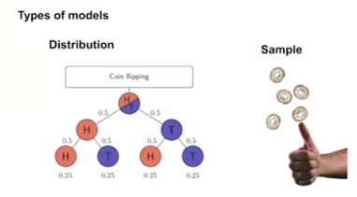
738. .
739. .
740. 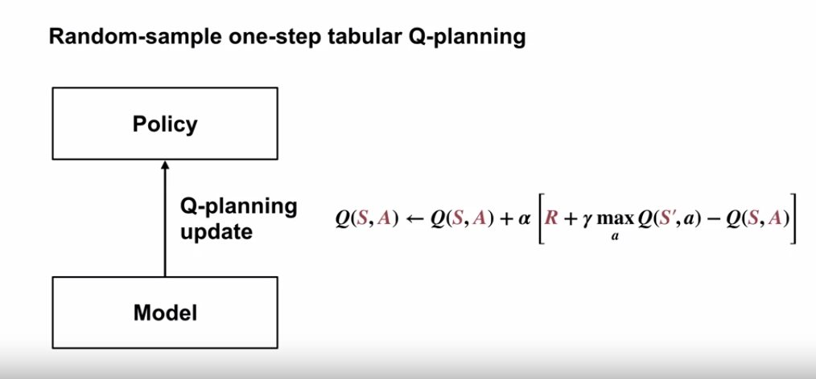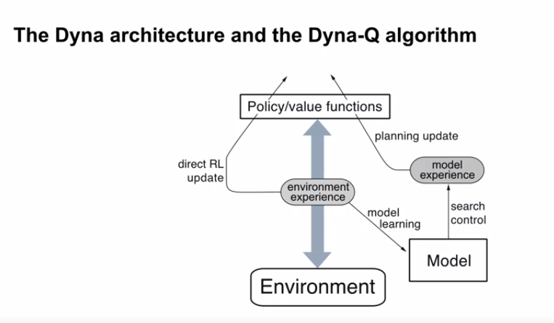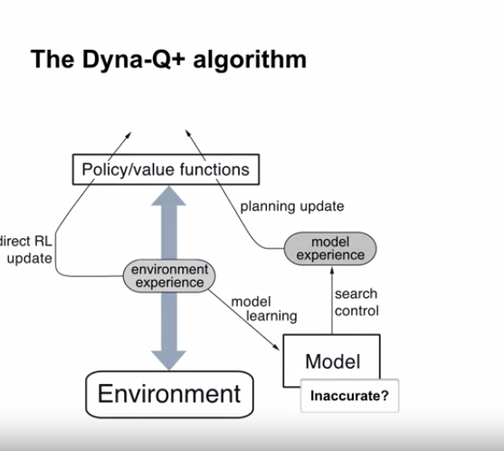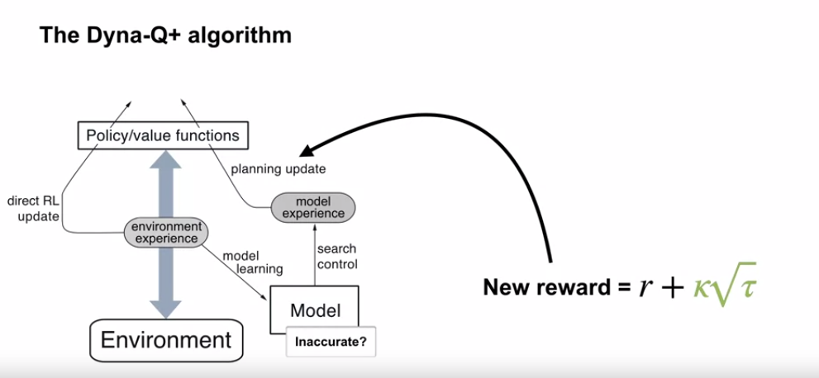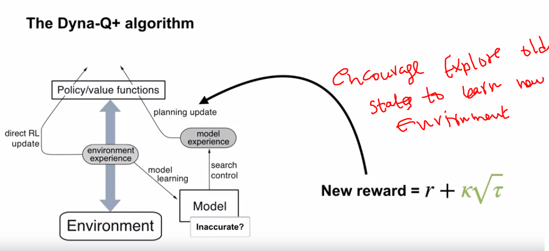

Quiz

